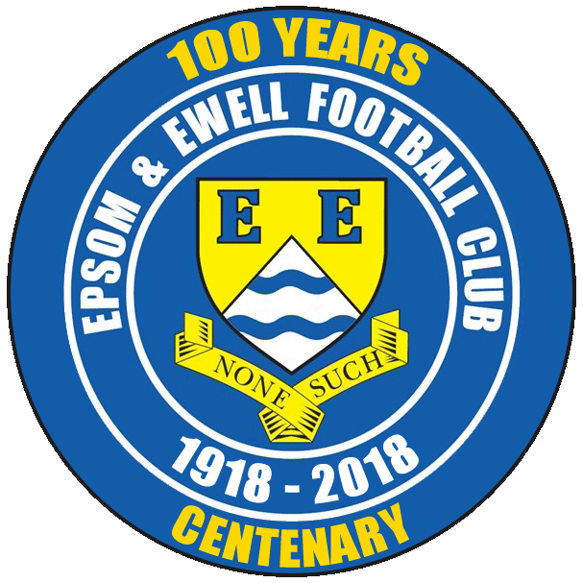 | Epsom & Ewell F.C.  16  v  Camberley Town F.C.  Saturday, 10th March 2018 – 3.00 p.m.
Good afternoon and welcome to High Road for a League match against our good friends Camberley Town. We welcome their players, supporters and officials and wish them a safe journey home, as of course we do for our own regular supporters.

It is well documented that Camberley Town are the opponents that we have met the most in our history with 91 previous meetings, (and another couple with our wartime club) but this is in danger of being our last for one season at least. Results have improved for us in recent weeks, but it doesn’t help when you get a creditable draw against a decent team like Knaphill, only to find that the teams around you have picked up wins! All we can do is our best and we’ll see where that gets us.

We drew at Camberley back in October when a Lloyd Connelly header on his debut earned us a 1-1 draw.

As referred to above, our last match came fourteen days ago when we welcomed Knaphill to High Road, and we registered our second consecutive goalless draw in a match that was largely dominated by the freezing and blustery weather. I believe it was the coldest Saturday we had spent at High Road and of course since then it’s been worse still with the heavy snow. Still, it made no difference to our fixtures as we had a bit of time off planned anyway, and this may help us as the season concludes, with the clubs around us having many more matches to play in just the seven weeks now.

Our match on Tuesday against CB Hounslow has now moved back to Tuesday 17th April although we are next here in three days for the visit of Balham in a match that was postponed on 20th January.

As we are now into March we can now celebrate our 100th anniversary properly! We don’t know the exact date of formation but I have been able to nail this down to March 1918 and we have a few articles relating to this in today’s issue. In fact, it’s a bit history heavy! I’m sure our opponents will not begrudge us the indulgence! On that note I’d like to thank our four contributors today who didn’t get an awful lot of notice if I’m honest!

Finally, Match and Player sponsorships are still available, so please help the Salts by sponsoring one or the other. Or both!

Enjoy the game!

Rich

Don’t forget, you can now follow us on Social Media. Please see the inside cover for addresses.

Historical Cover photos

- Epsom & Ewell F.C. line up ahead of our finest hour; the F.A. Vase Final in 1975
- One of our earliest team photos against Camberley & Yorktown in October 1924
1

Cherry Red Records Combined Counties League
Premier Division Table 2017/18
inc Tuesday 6th March | P | W | D | L | F | A | Pts | GD | H | A
Westfield | 30 | 27 | 1 | 2 | 111 | 28 | 82 | +83 | 14/4 | 0-5
Bedfont Sports | 32 | 22 | 4 | 6 | 83 | 48 | 70 | +35 | 24/3 | 0-7
Sutton Common Rovers | 32 | 22 | 3 | 7 | 67 | 37 | 69 | +30 | 0-2 | 0-5
Walton & Hersham | 32 | 20 | 6 | 6 | 67 | 36 | 66 | +30 | 0-2 | 24/4
Camberley Town | 31 | 11 | 17 | 3 | 44 | 33 | 50 | +11 | 10/3 | 1-1
Knaphill | 32 | 13 | 9 | 10 | 60 | 52 | 48 | +8 | 0-0 | 2-6
Horley Town | 30 | 13 | 6 | 11 | 48 | 57 | 45 | -9 | 2-3 | 2-3
CB Hounslow United | 29 | 13 | 4 | 12 | 48 | 39 | 43 | +9 | 6/3 | 2-4
Balham | 26 | 12 | 5 | 9 | 53 | 45 | 41 | +8 | 13/3 | 0-4
Hanworth Villa | 31 | 11 | 8 | 12 | 53 | 64 | 41 | -11 | 1-1 | 3-2
Spelthorne Sports | 33 | 11 | 7 | 15 | 50 | 53 | 40 | -3 | 1-5 | 0-0
Guildford City | 32 | 11 | 7 | 14 | 54 | 64 | 40 | -10 | 1-3 | 7/4
North Greenford United | 26 | 10 | 7 | 9 | 47 | 42 | 37 | +5 | 1-2 | 17/3
Redhill | 30 | 11 | 4 | 15 | 48 | 52 | 37 | -4 | 0-5 | 0-3
Abbey Rangers | 29 | 8 | 9 | 12 | 41 | 47 | 33 | -6 | 1-1 | 0-0
Chertsey Town | 31 | 9 | 4 | 18 | 52 | 70 | 31 | -18 | 2-7 | 0-1
Godalming Town | 31 | 8 | 6 | 17 | 38 | 65 | 30 | -27 | 0-3 | 2-1
AFC Hayes | 27 | 8 | 5 | 15 | 40 | 57 | 29 | -17 | 28/4 | 0-2
Colliers Wood United | 29 | 8 | 4 | 17 | 50 | 56 | 28 | -6 | 30/3 | 2-5
Banstead Athletic | 29 | 7 | 6 | 16 | 37 | 68 | 27 | -31 | 2/4 | 1-1
Farnham Town | 30 | 5 | 8 | 17 | 38 | 59 | 23 | -21 | 3-0 | 0-0
Epsom and Ewell | 31 | 3 | 8 | 20 | 27 | 84 | 17 | -57 | X | X

Lucky Day? – 10th March
Played 13 - W 8 D 2 L 3 - For 31 Against 22 - PPG 2.00 - Very Good
Our Club record against Camberley Town
Played 91 - W 38 D 23 L 29 Ab 1 - F 159 A 126 - PPG 1.51 - Above Average
Largest wins and losses against Camberley Town
3rd January 1953 - Won 9-1 - Surrey Senior Cup (H)
15th April 2006 - Lost 0-4 - Isthmian League (H)
5th November 2011 - Lost 0-4 - Combined Counties League (A)
Camberley Town’s Last Visit
Saturday 10th September 2016 - Drew 0-0 - Combined Counties League

Club Chairman - Peter Beddoe

Good afternoon to our loyal group of supporters and welcome also to the players, Officials and supporters of our good friends Camberley Town.

It’s a privilege to share a few memories and thoughts on our Club’s centenary in this souvenir programme. My first trip to West Street was on 8th October 1955 to see us play Dorking in the FA Cup; a match we won 3-2. My Dad and I travelled from Epsom to Ewell West by train on our “Privs” because Dad worked on the Railway (Steve D or Paul M will explain the terminology) and walked with a large contingent of Dorking supporters through Gibraltar Rec to the ground.

We won and I well remember the silky skills of the late Dave Hermitage. Another match that sticks in my mind was an Amateur Cup match against Sheppey United on 1st December 1956 where our equalizer was disallowed in a 3-2 defeat. There were some very irate supporters there on that day. I seem to remember a member of the cloth getting quite animated!

I was already going to the odd match at Stamford Bridge and then supported them long enough to see them add the FA Cup and the Cup Winners Cup to the Division 1 title they’d won in 1954-55.

My return to West Street, after being disillusioned by all my vantage points at Chelsea being knocked down, was the Altrincham F.A. Trophy match on 6th February 1982., which I attended with our son Dave perched on my shoulders; a great performance by the lads and a harsh defeat against a team that would go on to reach the Final.

More regular appearances then commenced through the 1980s and 90s, special memories of Tommy Tuite, Jimmy Richardson & Mark Cossey an elusive winger from New Zealand who never failed to perform in his few appearances. Also, I can still see Neil Robson dashing down the wing and finishing with excellent crosses, usually with Dave at West Street & Merland Rise and then latterly in our travels to Weldon Way (Moatside) & High Road.

Another match that stands out at West Street was on 6th December 1988 when our Youth team lost 11-0 to an excellent Arsenal team in the FA Youth Cup.

Most of you will remember the recent highs and lows so I won’t elaborate, save to say that off the pitch our attempts to relocate back to the Borough were continually thwarted. As a means of securing the future of the Club for the next 100 years we are in the process of negotiating a part of Hook Road Arena for our use. It is a joint venture with the Colts and it will be very much a Community project. As a first step we have just presented our Vision of this relocation project at Epsom Town Hall to the Group of Residents Association Councillors. It was well received, without any negative comments.

It is only the first step in the process of relocation, but I will keep you informed of developments. I’ve been promised that our Vision will be on the Agenda for discussion at their next meeting. Neil Grant, our new manager, is being kept fully informed and is very supportive of this project. He needs a home in the Borough to encourage players to join us.

We look back with pride over the Club’s achievements in the past 100 years and long may the Club continue to prosper.

Pete

Club Manager - Neil Grant
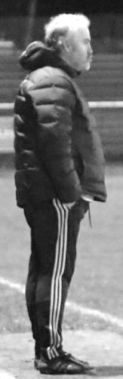
Good afternoon to all our supporters and I also welcome Camberley Town, their supporters and management too. I hope you have a safe journey home.

Firstly, I’d like to congratulate Epsom and Ewell F.C. for reaching a magical 100 years and all the people involved with The Salts. Long may this continue and it’s a great credit to all that kept this fine club going, especially in the last 25 years having to play outside the borough following the sale of their ground. I’m hopeful that while I’m Manager I can someway help towards Epsom and Ewell returning to the borough and finding the own home.

I’m also working towards a closer relationship with Epsom and Ewell Colts and having met officials last week I feel that the future is bright for both parties and am looking forward to developing the relationship between the two clubs, and as I promised I will attend as many youth games as I can before the end of this season.

Since my appointment in January, which I’m pleased to say and accept is now a permanent role, I feel on the pitch we are going in the right direction. Taking out the game with Merstham in the Surrey Senior Cup our League form has greatly improved, losing only to Sutton Common Rovers in the games I’ve been in charge.

Having worked under some very good Managers and coaches during my time at Leatherhead I’ve tried to bring in what I believe will give us a chance and I’m really pleased how the players have responded, especially at training where we train twice a week. Last Saturday’s game with Knaphill just show how much these players care with great desire in their defensive play and keeping another clean sheet. I know there are lots of improvements to be made especially in the final third. Keeping clean sheets gives us a chance and now we need to step up and start creating and taking our chances that will win us games of football.

I’m pleased how the squad is shaping up and we are looking at a very strong 20 man squad, so competition for places is key to my philosophy and the way I believe. Having made an arrangement with Ashtead F.C. players on the fringe are getting game time under their belts hoping to force their way into the match-day squad.

With 11 games to go and still plenty to play for, I still believe we can pull this off and really enjoy the 100 years at the end of season and more importantly the players believe so please enjoy the ride and make the 12th man as we continue survival mode.

Enjoy the game!

Neil

Club Captain - Alex McKay
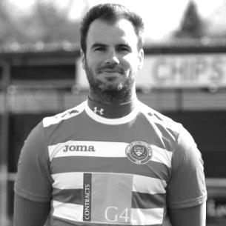
Epsom and Ewell FC have gone through a great deal of change since my club debut in 2008. When I first joined 'The Salts' were ground sharing with local rivals Banstead Athletic at Merland Rise. This was followed by another move to Merstham FC for a couple of seasons before eventually arriving at our current home away from home and in my opinion the best pitch that we have had the pleasure of calling home in Chipstead Football Club.

As with any team, change is inevitable and the teams I have been a part of in my two spells at the club have gone through highs and lows but have always ultimately adapted to the situation and through perseverance come out better off.

In my first couple of seasons, Epsom was a solid mid-table team that battled, was difficult to beat but at the same time quite unpredictable and didn't play the most eye-catching of football. This however changed over time with hard work, better facilities and ultimately better players that elevated Epsom to being a club that was a recognized top four contending team in the CCPL in recent years. I have been lucky enough to play in two very good Epsom teams over the past decade that has not only had a distinctly improved style of play but also shared many highlights that will go down in club history.

The first of these was winning the club's most recent piece of silverware in the League Cup in 2013, which is even more impressive now in the fact that all of the teams that we beat in the final rounds (Guernsey, Egham and South Park) have since gone on to be promoted and still play in the Ryman South. That final step up however always seemed to elude us for whatever reason in my time at the club, with our best league position being third. That same year saw my first ‘weekend away’ fixture, with our last game of the season being an away trip to league champions Guernsey. We narrowly lost a close fought battle 2-0 in the dying minutes of the game but the nature of the trip meant that we were still able to enjoy an end of season celebration before our return flight back home.

This element of travel links to my final club highlight, which was our invitational trip to represent the borough of Epsom and Ewell in Chantilly, France during the 2016 Euros. Needless to say our ‘narrow’ loss was but a minor detail in what was a once in a lifetime roller coaster experience that saw us take part in a civic reception, meet Roy Hodgson, get mistaken for the England team, signing autographs, babies, and shirts, stopping traffic and all the while regaling the town with the chant of our only Euro 2016 goal scorer, in the style of Will Grigg’s on fire… “Hendo’s on cider!” To top this all off the whole thing had received a running commentary that was broadcast not only to Talksport radio’s twitter feed, due to us coincidentally sharing our evening of celebrations in the same bar as its host Adrian Durham but also managing to make a slot on the evening London Tonight news.

Although I have shared many memorable highs with this club there have also been some lows and statistically no more so than our current league situation this season. It has been a very difficult season for the club but I am pleased to say that we now seem to have a squad of players that are good enough to produce results when we work together as a team. This final leg of the season won’t be easy but I genuinely believe that if we can continue to work hard and follow the direction and vision that has been laid out to us by the management team, that we are still able to come away with something and provide a solid base from which to kick on and again strive for success next season.

Recent Results and Fixtures
Combined Counties League – Saturday 24th February 2018
AFC Hayes | 1-2 | Banstead Athletic
Balham | 0-1 | Walton & Hersham
Bedfont Sports | 1-0 | North Greenford United
CB Hounslow United | 3-2 | Abbey Rangers
Epsom & Ewell | 0-0 | Knaphill
Godalming Town | 1-4 | Westfield
Guildford City | 0-1 | Sutton Common Rovers
Hanworth Villa | 1-1 | Farnham Town
Horley Town | 0-0 | Camberley Town
Redhill | 4-0 | Chertsey Town
Spelthorne Sports | 0-4 | Colliers Wood United
Combined Counties League – Saturday 3rd March 2018
Abbey Rangers | p-p | Guildford City
Camberley Town | p-p | Banstead Athletic
Chertsey Town | p-p | Balham
Farnham Town | p-p | Redhill
Hanworth Villa | p-p | Horley Town
Knaphill | p-p | CB Hounslow United
North Greenford United | p-p | Godalming Town
Sutton Common Rovers | 4-1 | AFC Hayes
Combined Counties League – Tuesday 6th March 2018
Abbey Rangers | 1-1 | Camberley Town
AFC Hayes | 1-0 | Colliers Wood United
Chertsey Town | 3-2 | Farnham Town
North Greenford United | 1-0 | Banstead Athletic
Combined Counties League – Wednesday 7th March 2018
Balham | 3-2 | Horley Town
Guildford City | 0-2 | Walton & Hersham
Combined Counties League – Friday 9th March 2018
Balham | V | Colliers Wood United
Combined Counties League – Saturday 10th March 2018
AFC Hayes | V | Bedfont Sports
Banstead Athletic | V | Redhill
CB Hounslow United | V | Farnham Town
Epsom & Ewell | V | Camberley Town
Godalming Town | V | Abbey Rangers
Guildford City | V | North Greenford United
Horley Town | V | Spelthorne Sports
Knaphill | V | Hanworth Villa
Walton & Hersham | V | Sutton Common Rovers
Westfield | V | Chertsey Town
Recent Results and Fixtures
Combined Counties League – Tuesday 13th March 2018
AFC Hayes | V | Walton & Hersham
Banstead Athletic | V | Bedfont Sports
Epsom & Ewell | V | Balham
Hanworth Villa | V | Horley Town
North Greenford United | V | Camberley Town
Redhill | V | CB Hounslow United
Combined Counties League – Wednesday 14th March 2018
Colliers Wood United | V | Chertsey Town
Combined Counties League – Saturday 17th March 2018
Bedfont Sports | V | Camberley Town
Chertsey Town | V | AFC Hayes
Colliers Wood United | V | Knaphill
Guildford City | V | Westfield
Hanworth Villa | V | Godalming Town
Horley Town | V | Banstead Athletic
North Greenford United | V | Epsom & Ewell
Redhill | V | Balham
Spelthorne Sports | V | Abbey Rangers
Sutton Common Rovers | V | Farnham Town
Walton & Hersham | V | CB Hounslow United
Combined Counties League Cup SF – Tuesday 20th March 2018
Walton & Hersham | V | Knaphill
Combined Counties League – Tuesday 20th March 2018
Bedfont Sports | V | Godalming Town
Farnham Town | V | Colliers Wood United
North Greenford United | V | Westfield
Combined Counties League – Wednesday 21st March 2018
Balham | V | AFC Hayes
Combined Counties League Cup SF – Saturday 24th March 2018
Worcester Park | V | Sutton Common Rovers
Combined Counties League – Saturday 24th March 2018
Abbey Rangers | V | Horley Town
AFC Hayes | V | Guildford City
CB Hounslow United | V | Chertsey Town
Colliers Wood United | V | North Greenford United
Epsom & Ewell | V | Bedfont Sports
Farnham Town | V | Knaphill
Godalming Town | V | Spelthorne Sports
Hanworth Villa | V | Redhill
Westfield | V | Banstead Athletic

From behind the goal
Epsom & Ewell 0-0 Knaphill
Combined Counties League - Premier Division - Saturday 3rd February 2018

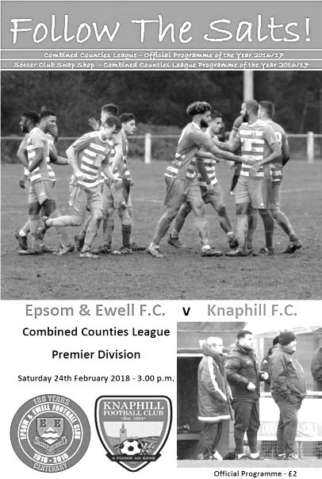
Salts defend superbly to earn another point

This is our seventh season at Chipstead and I am certain that we have not had a colder Saturday since we started playing there!

High Road is often a cold venue, but this week we also had an icy wind to give added bite for those who had dared to brave the elements, including our match sponsor, long-serving Jack Jarman, who is well into his eighties!

Clearly the weather had an effect on the less hardened supporters as the attendance was limited to 37, but those who were there can attest to the fact that our boys fought really hard once again to secure a point in a match that was very similar to our last encounter with Abbey Rangers.

We had a few changes this week. Noah Stew-Lewis was unavailable, but Endrit Dobraj was back and stepped straight back in at right back, while on the left Ben Franklin was also absent so Shaun Masterson came in. Both did excellent jobs dealing with the visiting wingers. In the centre Alex McKay was injured and so Reisse Griffin paired up with Adam Heagney.

In midfield Ashley Thompson came back after absence last week in place of Miguel Anderson who dropped to the bench and Liam Roberts came in for the working Marlon Pinder. We were also due to see the return of Elliott Thompson after he suffered a horrible injury at Windsor in August of 2016, but he broke down in the warm up and Rory Sellick kept his place.

The opening exchanges were mainly in the visitors favour and Heagney almost found his own net when he cleared a dangerous ball out for a corner after just ten minutes. However, it looked as though Knaphill had gone ahead in the 16th minute when Danny Taylor broke through on goal, deceived Conor Young and looked set to roll the ball into an empty net, yet somehow the lightning fast Reisse Griffin was able to get back and clear the ball off the line!

The visitors would go on to regret that missed opportunity, although they had another good chance in the 36th minute when the ball pinged around in our area for what

seemed like ages; the ball eventually being claimed by Young on the goal line. We had created little to this point, but Roberts found himself with a great opportunity just eighteen yards out and keeper Jordan Clement in no man's land. However, he scuffed his attempt straight at him. Clement made a good save a few minutes later as Roberts got a good strike on goal that was creeping inside the far post before Kyen Nicholas saw his effort from Dobraj's cross deflected over the bar.

Young was down swiftly to gather a powerful drive from the angle of the penalty area at the second attempt but ultimately the weather was the real winner as the blustery conditions and very firm surface made it difficult to create much. The only other item of note to report as the first half ebbed away was the replacement of the injured Griffin by our Coach Jordan Clark.

The second half continued in a similar vein with the visitors doing most of the pressing as we struggled to look after the ball well enough. We had a scare just five minutes in when a deep left wing delivery was missed by Young and the shot at the far post was blocked away, as were two more attempts from the subsequent corner. However, most of the deliveries in were just providing Young with catching practice.

Germaine Jeannoel replaced Nicholas and shortly after his introduction his set up enabled Roberts to get a strike on goal, but he dragged the ball beyond the far post from nearly twenty yards. Heagney delivered a free kick soon after this which was left by everyone and nearly crept in at the far post.

Most of the opportunities were still falling to the visiting side who, as with last week's match against Abbey Rangers, were pushing for a winner. Their Captain Jimmy Norman had a shot superbly charged down by Dobraj from just ten yards out before Young deflected a low shot over his bar at his near post.

However, in the 88th minute we had a golden opportunity to pinch the points as Jeannoel got through on goal with just Clement to beat, but from only eight yards he poked his shot inches wide of the keeper's left hand post! In the end it nearly cost us the point we had worked so hard to earn as Young had to make a wonderful double save in the 90th minute when a goal appeared inevitable, so that we were able to preserve it.

This draw ensures that we have just one defeat in our last seven League matches but unfortunately the club nearest to us, Farnham town also picked up a point, and worse still, nearby Colliers Wood United and Banstead Athletic both won. We should be really pleased with a point against a team in good form and in the top six, but the League table now looks worse than it did before kick-off. Harsh!

Epsom and Ewell: Conor Young, Endrit Dobraj, Shaun Masterson, Adam Heagney, Reisse Griffin, Ashley Thompson (c), Liam Roberts, Scott Murphy, Kyen Nicholas,
Rory Sellick, Lloyd Connelly

Subs: Jordan Clark for Griffin (27), Germaine Jeannoel for Nicholas (56),
Miguel Anderson for Connelly (66)

Club Treasurer - Steve Dyke

A centenary is always an occasion to reflect and I realise I’ve been around to a greater or lesser extent for over 45 of those years and have family connections going back further.

The first Epsom and Ewell game I remember fully going to was a small low profile affair on 19th April 1975 at Wembley against Hoddesdon Town, although I have memories of being at West Street before then. It was a massive event with 5,000 people leaving Epsom on about 100 coaches that day and a big dividing line amongst my generation of school mates (I was 9); those who did go to Wembley got into football, those who didn’t, didn’t! My life since has been a 45 year plus attempt at disproving the allegation I was a glory hunter.

As a family we were only occasional supporters at that time. My dad Wally was the Manager of the Co-op at Tattenham Corner and worked on Saturdays. In fact the first team I regularly got into the rhythm of supporting was Banstead Athletic in 1978 as I’d get the bus up to Merland Rise and get a lift home with dad.

When he retired in 1983 we started coming to West Street regularly, Mum, Dad and Geoff became regulars at the Bingo club run by Pam Cook in the old Board room and Dad started helping out with ground maintenance. The longest serving supporter in the family was Uncle Ted, he had been watching Epsom possibly as far back as the 1940’s and stood by the players gate at West Street and he would help out with odd jobs around the ground and we would be regaled with stories about the likes of Ernie Watkins from his friends Claude George and Max Wall who also stood in that area.

We got into the rhythm of watching games home and away and although for a while my loyalties were split with Bristol City (it’s a long story) and four years up in Sheffield at University, I returned after dad passed away in 1994. I took up the mantle of Geoff and I going every week home and away to watch Epsom. Sadly the last quarter of our history we have not had a home of our own but it is a tribute to those who’ve kept the flame alive that we are still here at all after such a long spell of ground sharing. We hope that there may be possibilities developing to bring that long exile to an end.

One of the best things about what has been a difficult season is that my son Sam has caught the football bug this year and has become a very enthusiastic supporter. He spent some of his Christmas money on a flag he designed to celebrate our family’s support of the club over the years and it will be on display around the half way line in front of the stand.

My memories – Best player seen (The Tommy Tuite question) – Tommy Tuite
Favourite player – Stuart Miller – a very hardworking forward who came to us when we were at a low ebb and helped revive us
Best goal – Tempted to say with the recency effect Reisse Griffin’s solo effort at Rusthall but Sam Currie’s screamer in the League Cup Final in 2013 was pretty special.
Likes – Hard working players , backs to the wall 1-0 wins,
Dislikes – Player exoduses – Epsom people watching football at Gander Green Lane!

Club Records - 10th March
Date | Day | Competition |  | Opponents |  | Scorers
10/03/28 | Sat | East Surrey  Hospital Cup SF | H | Redhill | 7-2 | F.Behn (3), J.Parr, R.Marlow, F.Watts, H.Westlake (pen)
10/03/34 | Sat | London League | H | Chelmsford | 1-0 | L.Marlow
10/03/51 | Sat | Corinthian League | A | Chesham United | 3-8 | F.Boatwright (2 pens), S.Faggetter
10/03/56 | Sat | Corinthian League | H | Uxbridge | 1-0 | B.Jenkins
10/03/62 | Sat | Corinthian League | H | Dorking | 3-4 | K.Brown (2), J.Leedham
10/03/73 | Sat | Athenian League 2 | A | Ruislip Manor | 3-4 | A.Howe, C.Rose, o.g.
10/03/79 | Sat | Isthmian League 1 | H | Aveley | 3-0 | T.Tuite (2), J.Hunn
10/03/90 | Sat | Isthmian League 2s | A | Camberley Town | 0-0
10/03/92 | Tue | Isthmian League 3 | A | Eastbourne United | 1-0 | A.Webster
10/03/01 | Sat | Isthmian League 3 | A | Ashford Town (Mx) | 1-0 | A.Nimmo (pen)
10/03/07 | Sat | Combined Counties  Premier Division | A | Dorking | 2-2 | o.g., D.Marvell
10/03/12 | Sat | Combined Counties  Premier Division | A | Mole Valley SCR | 4-2 | M.Jarman, P.Gough, J.Cottee, N.Ayling
10/03/15 | Tue | Combined Counties  Premier Division | A | Raynes Park Vale | 2-0 | S.Robinson, K.Hough
Historical Decades
90 years ago – Epsom Town F.C.
03/03/28 | Sat | London League | H | Custom House | 5-2 | R.Marlow (3), J.Parr (2)
80 years ago – Epsom F.C.
05/03/38 | Sat | Surrey Senior Cup SF | N | Dulwich Hamlet | 2-2 | T.Rochester, A.Bruce
70 years ago – Epsom F.C.
06/03/48 | Sat | London League | A | Ekco | 2-3 | T.Rochester (pen), B.Cutter
60 years ago – Epsom F.C.
08/03/58 | Sat | Corinthian Memorial Shield SF | A | Yiewsley | 1-5 | K.Harris
50 years ago – Epsom & Ewell F.C.
09/03/68 | Sat | Athenian League  Div 2 Cup SF | A | Windsor & Eton | 3-2+ | W.Lewis (pen), C.Kelly, J.Eales
40 years ago – Epsom & Ewell F.C.
06/03/78 | Mon | Isthmian League 2 | A | Worthing | 3-1 | J.Hunn (pen), T.Tuite, S.Delaney
30 years ago – Epsom & Ewell F.C.
05/03/88 | Sat | Isthmian League 2s | A | Petersfield United | 3-2 | B.Perkins, R.Kidd, L.Harding
20 years ago – Epsom & Ewell F.C.
07/03/98 | Sat | Isthmian League 3 | A | Hertford Town | 1-2 | S.Smith
10 years ago – Epsom & Ewell F.C.
04/03/08 | Tue | Combined Counties  Premier Division | H | Chertsey Town | 0-1

History Corner – 10th March
90 years ago this week we continued our push for the London League title and defeated Custom House 5-2, leading by four clear goals at half time with Reg Marlow scoring three and Jack Parr getting the other two. (see programme right) This programme is the second oldest home programme I actually own! Custom House were based in the East End of London and part of their ground from that era now sits under the Olympic Park!

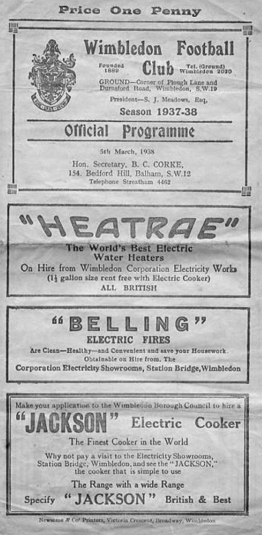
80 years ago this week we visited Plough Lane, home of Wimbledon for a Surrey Senior Cup Semi-Final against Dulwich Hamlet, drawing 2-2. The goals from Tommy Rochester and A.Bruce were the first conceded by the Hamlet in the competition. They had also won the Cup the year before without conceding. Unfortunately we were unable to win the replay, bowing out narrowly at Richmond Road, home of Kingstonian. (see programme right).

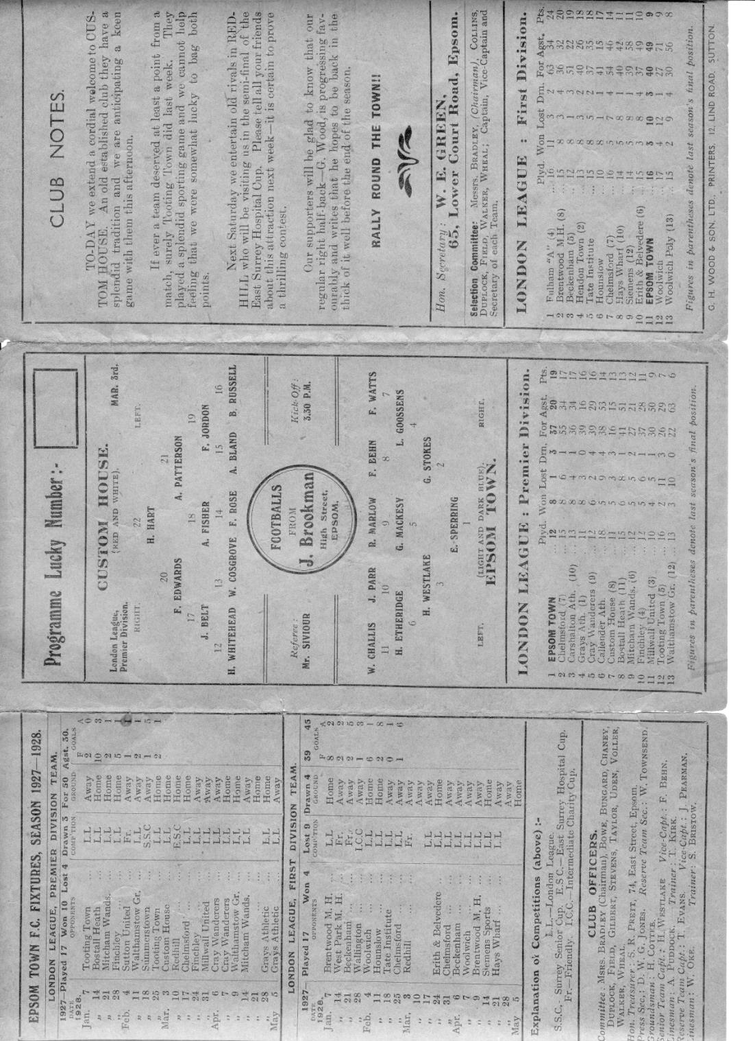
64 years ago this week and sixteen years almost to the day since the match I just referred to, history repeated itself as we again visited Plough Lane, for a Surrey Senior Cup Semi-Final against Dulwich Hamlet (see programme across page). In front of over 6,000 spectators and again we held the Isthmian giants to a draw, 1-1 this time and on this occasion we would win the replay at Sandy Lane, Tooting & Mitcham United to reach the Final! The Final would contain another large crowd at Selhurst Park but Corinthian Casuals would be the winners on the day by two clear goals, even if it was against the run of play!

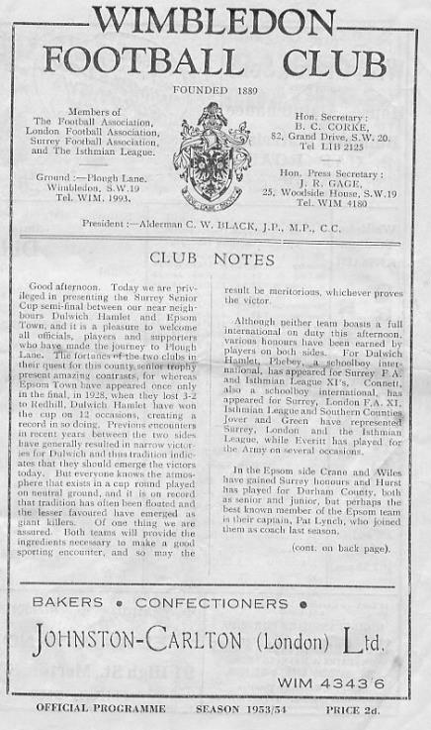
60 years ago this week we visited the unusually named Falling Lane, home of Yiewsley for a Corinthian League Memorial Shield Semi-Final. They were a good team and would win 5-1 before turning professional and joining the Southern League under the name of Hillingdon Borough.

50 years ago this week we visited Stag Meadow for another Semi-Final, this time for the Athenian League Division Two Cup. The two teams were well matched and the tie went to extra time before a Wayne Lewis penalty clinched us a place in the Final with a 3-2 win. Unfortunately the two-legged Final against Edmonton was an anti-climax as the opposition won 7-0 on aggregate. (see programme below)

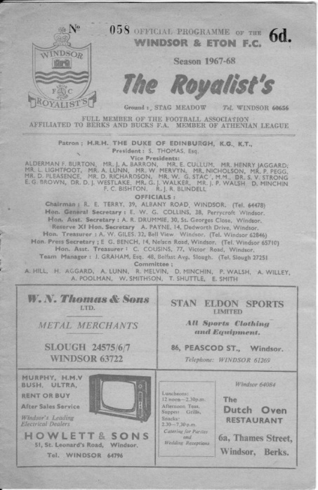
45 years ago today we visited League leaders Ruislip Manor and gave them a real fright. In one of our last matches of the season we were once again fighting relegation; a battle we would lose, but we led here 3-2 thanks to an own goal and strikes from Colin Rose and Alan Howe. Unfortunately we couldn’t hold on and were narrowly defeated by four goals to three.

11 years ago today we were rebuilding our season under new Manager Lyndon Buckwell but this one was a disappointing result. We led twice; the first coming from future player Charlie West, (who was playing for Dorking at the time) and the second time from Dale Marvell but we couldn’t hold on and drew 2-2 but it didn’t matter as we were safe by then.

Happy Anniversary!
Earlier this week I asked all of our Twitter and Facebook followers to wish us a happy Anniversary and a large amount replied from far and wide. Here they all are (so far):

Matthew Fance: Happy Anniversary 💯

John Wheatley: Happy Birthday Salts from Tuscaloosa, Alabama! 🎉

Scott McNeish: Happy Anniversary! I've seen you play twice, and you've won both times! 100% record!

Councillor Vince Romagnuolo: Happy anniversary the #Salts. Hoping you’re back home in the borough before too long, let’s make it a double celebration #saltscentenary

Steve Davies: Happy Anniversary! (Do you still get a Telegram from the Queen?)

Eclipse Sports: Happy Birthday, the big 100..... great effort. Anniversary kit in order!!

Adam Deadman: congrats

Graham Banyard: Happy anniversary guys. Great club with many great people behind it over the years and one that I wished I got the chance to manage a number of years ago when I left the now defunct Mole Valley Predators!

Caroline McRoyall (SCFA Chief Executive): Congratulations on reaching 100 years...time to update @surreyfa club honorary board.👏👏

Sam Dyke: Happy 100th, wish I had got into football earlier

Chris Clapham (Colliers Wood United FC): Catching up! Congratulations

Andy Lunn: Happy 100th anniversary Epsom & Ewell, I remember playing at West Street

Badshot Lea FC: Welcome to the 100 club!!

Gareth Coates: Happy anniversary to a great club. The #SaltsCentenary is a real milestone, especially given how long the club has been nomadic.

Vedran Deranja: Huge congratulations to everyone associated with @EEFCOfficial on their 100th anniversary! Keep playing a beautiful game.
#hundredyearsyoungnotold

Jim Dean MBE: Happy 💯 Anniversary @EEFCOfficial - hope it won’t be too long before you’re back playing in the borough you belong!

Neil Grant (Club Manager): Happy 💯 years @EEFCOfficial. Great people and it’s a honour to be their 1st team Manager. Looking forward to the future and long may their history continue #salts ⚽️🔵⚪️🔵⚪️💯

Molesey FC: Happy 100 year anniversary to all at Epsom and Ewell FC from us over at Molesey FC. Here’s to the next 100 years

Karen from Suddies in Epsom: Congratulations 100 years and still in the game. #saltscentenary 🏆🥇⚽️🥅🥇 http://www.eefconline.co.uk

Ed Vanson: Happy birthday to @EEFCOfficial who are 100 years old! Superb. We need you back in epsom and ewell one day!

Philip Harris: Many congratulations on reaching your centenary. Proud to say I've followed you for over half that time. Here's to the next one hundred years!.....and a home in the borough.

John Cook (former player): Happy 100th, enjoyed my time as a player there hope you get back home soon

David Lawton: Happy Anniversary to EEFC. Let’s get you back in the borough to celebrate.

Ricky Borrett (former player): Happy anniversary to the club that took me from Sunday league football to non-league youth football that started my non-league football career always grateful and happy anniversary ⚽️⚽️⚽️

Dave Lewis: Congratulations to @EEFCOfficial on their 100th Birthday. Many happy memories of attending games at West Street. Would be great if @EpsomEwellBC could help the club find a new home soon.

FA Cup FactFile: Congratulations on achieving 100 years. You were my first ever local #NonLeague club that I followed regularly and you were the reason for my first ever trip to #Wembley. Despite that #FAVase result, that day is still one of my fondest ever memories. #saltscentenary

Terry Bullweather: Congratulations and all the best for the next 100 years 👊⚽️🏆

Nigel Stickland: One hundred year anniversary for Epsom and Ewell FC @EEFCOfficial CONGRATULATIONS

What’s On in Epsom: Happy Birthday!

Theresa Ingrisano: Another 100 to come. Happy Anniversary.

Epsom & Ewell Old Boys FC: @EEFCOfficial Happy 100th Anniversary! Best of luck for the years ahead. #saltscentenary

Fareham Town: @EEFCOfficial happy birthday

Alick Potter: I watched the salts in the 1950s to 60s at West Street Ewell with my grandfather.

Tom Vandepeer: My encounter with your club was being an assistant in the FA Vase at Ringmer back on 24th September 2011. What I remember a very professional club. Happy 100th Anniversary.

Richard Humphreys: Many Congratulations on achieving your centenary Epsom and Ewell FC. I enjoyed following the club through the 1970s including @wembleystadium in the @FootballAssoc Vase in 1975. Hope you get back to your home borough soon.

Congratulatron: congratulations!

Simon Pearson (Chipstead FC): Congratulations on your 100th birthday... always good games at youth and mini soccer levels. Happy birthday from all at Chipstead FC.

Garry Abrams: Congrats, will there be an anniversary programme? Ed: Yes, you’re in it!

International Surrey Football: Happy Anniversary on the impressive milestone @EEFCOfficial 👏 #SurreyFootball

Sam Pye: Happy anniversary guys! I remember seeing the team 25-odd years ago at the old ground with my dad, Jeff Pye, who still goes with Arnold to this day. Here's to the future!

Wythenshawe Amateurs: Happy Anniversary from Wythenshawe Amateurs FC

Scott Murphy: Salts 💯 not out! 👏🏻👏🏻🙌🏻🙌🏻 🔵⚪️🔵⚪️ @EEFCOfficial

Gordon Foster (Rainworth Miners Welfare) Happy centenary from @RainworthMWFC in snowy Notts. We have four more years to wait for ours so, as I’m getting on a bit, hope I’m still around to see it.

Brendan Ruddle: I can remember 50 years ago George Nathan serving primroses in the bar at West Street and Russ Conway playing 'Sidesaddle' over the tannoy.
Here's to the next 50 - Come on the E's

Fatima Patel: Congratulations

Alb Bullen: Happy anniversary, let’s hope there’s a few more anniversaries to come. Come on you Town/blues/E’s/salts! 👏

George Holland: Happy Anniversary to The Salts, here's to the next 100 years. And hope fully a ground back in the Borough of Epsom and Ewell.

Tonny Giesen: Happy Anniversary to Epsom and Ewell FC!! Hello Salts!! Many congratulations from Dutch almost 101 years old Keijenburgse Boys.

Billericay Town FC: CONGRATULATIONS 👏 Best Wishes from BIllericay Town F.C. 💙👍🇬🇧

Paul Butler (former player): Congratulations to one of my ex clubs on getting to 100 years formed. 👍

Cliff Pointer: Congrats on 100 years Epsom and Ewell FC!!

Bornatotter: All the best to @EEFCOfficial on their centenary. Tough times for the club at the moment but they are born fighters. Remember going to the old ground in Ewell with my old man many years ago. Tragic loss that. Bout time local MP and Man Utd fan Grayling pulled his finger out.

Daniel Miller: Happy 100th Birthday Epsom & Ewell F.C. - a century of representing the community is fantastic & congratulations #thesalts

And finally…….

Matt Elliott (former player and Scottish International)
Great to hear the club is still going strong, have loads of brilliant memories from the old days as a kid watching and then playing at West Street! Happy Birthday and all the best to everyone still involved!!👏

Camberley Town – History
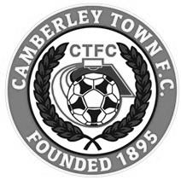
The football club was founded at St. Michael’s Church in Yorktown in 1895 and was initially named St. Michael’s, Camberley. The first trophy was won in the club's second season when Norwood & Selhurst were beaten 2-1 in the 1898 Surrey Junior Cup final. The club joined its first league, the East & West Surrey League, for the 1898-99 season and finished third.

In 1901 the club looked likely to fold for financial reasons but, after a public meeting, a new club named Camberley & Yorktown was formed by members of the St. Michael's committee. Camberley & Yorktown took the place of St. Michael's in the East & West Surrey League before joining the Aldershot Combination in 1902 followed by the Ascot & District League in 1903 where the club won four titles and finished second three times in the seven years spent in the league. The club went on to appear in three more Surrey Junior Cup finals, the first of which was in 1908 when Camberley & Yorktown took on Kingston at Woking and were beaten 2-0. The following season also resulted in a defeat in the final this time losing 1-0 to Selhurst Park. The 1909-10 season saw victory at last as Camberley & Yorktown defeated Sutton United 2-1 at Kingston.

The club moved to the West Surrey League in 1910 and in 1913 made their first appearances in both the F.A. Cup and F.A. Amateur Cup. On September 13th Camberley & Yorktown played host to Sutton United and won 5-3 in their first F.A. Cup match. The first F.A. Amateur Cup game was disappointing though as Camberley & Yorktown were soundly beaten 7-0 by the Royal Army Medical Corps, however the club went on to win the league title that season.

After World War I Camberley & Yorktown concentrated their efforts on the Aldershot Senior League until 1922 when the club submitted an application to join the newly formed Surrey Senior League. The application was accepted so Camberley & Yorktown became founder members of the league and remained in it for over 50 years. The club moved into their present ground at Krooner Park in 1923. The ground had been paid for from the winnings of a racehorse named 'Krooner' at Haydock Park in 1920. The 1930’s saw unequalled success at the club as they won the Surrey Senior League title three seasons running from 1931 to 1933 and appeared in the final of the Surrey Senior Cup in 1936 where they were beaten 3-1 by Wimbledon at Champion Hill, Dulwich.

After World War II Camberley & Yorktown dropped the 'Yorktown' part of their name. Krooner Park was not ready for use by the time the league resumed after the war so the club started the season at the London Road Recreation Ground which had been one of the grounds used before the move to Krooner Park. Success was hard to come by with only a victory in the Surrey Senior Charity Cup in 1952 against Chertsey and a further appearance in the final 3 years later to show for their efforts during the 50s and 60s.

In 1967 discussions took place regarding a merger between the club and the other senior club in the town, Camberley Wanderers. Wanderers had been formed as a youth football club in 1950 but moved into adult football in 1965 joining the Parthenon League

but they had no ground of their own. On the 2nd of June 1967 the merger went through and both clubs became Camberley Town F.C. The first notable season as Camberley Town came in 1972-73 when third place was achieved in the league alongside an appearance in the League Charity Cup final at Weybridge where they lost 3-2 to Westfield. In a bid to bring a higher grade of football to the town the club joined the Spartan League in 1973 and installed floodlights in 1974. The official opening of the floodlights saw what is believed to be a record home attendance of around 3,500 people watch Camberley draw 1-1 with Malcolm Allison's Crystal Palace team.

In 1975 Camberley joined the Athenian League followed by the Isthmian League in 1977. Promotion to Division One of the Isthmian League was achieved in 1979 along with victory in the final of the Surrey Senior Cup where Leatherhead were beaten 4-1 after extra time at Imber Court. However, collapse soon followed and within three seasons Camberley found themselves back in the Athenian League and struggling on and off the pitch. Expansion of the Isthmian League in 1985 gave Camberley a route back into the league which was gratefully accepted.

In 1986 the Club enjoyed their best run in the F.A. Vase reaching the quarter finals where they went out to eventual winners Halesowen Town. The Aldershot Senior Cup was won in 1997 and 1998. 1997-98 also saw Camberley reach the Fourth Qualifying Round of the F.A. Cup equalling their best performance in the competition since the 1930's. In the league they missed out on promotion on the final day of the season. In 1998-99 Camberley went one better in the F.A. Cup reaching the First Round Proper for the first time where they were knocked out by Division 3 side Brentford.

Following the disbanding of the Isthmian League Second Division in 2006 Camberley were placed in the Combined Counties League and have since secured their best run of league placings for many years. In 2009 the club won the Combined Counties Premier Challenge Cup for the first time beating Worcester Park 3-0 in the final at Carshalton Athletic F.C.

Current first team manager Dan Turkington took the helm during 2012-13 season. The club finished in second place in the league in both 2014 and 2015. 2015 saw the club winning two cup competitions in one season for the first time. Colliers Wood United were beaten 2-1 after extra time in the Combined Counties Premier Challenge Cup final at Woking F.C. and Fleet Town were beaten on penalties after a 0-0 draw in the Aldershot Senior Cup final at Aldershot Town F.C.

The 2015/16 season was a memorable one, even if ultimately the club ended with little to show for their efforts. Most importantly the club repeated their 1985/86 achievement in reaching the Quarter-Final of the F.A. Vase only to lose out 3-2 in extra time at eventual finalists Hereford after leading twice. The League was equally frustrating as a defeat to Hartley Wintney on the final day of the season meant that they just missed out on a third consecutive second place. This time it would have earned promotion and insult was added to injury when Farnham Town defeated them 3-1 in the Combined Counties Premier Challenge Cup Final, although a measure of revenge was gained as they defeated the same opponents to win the Aldershot Senior Cup.

Every Opponent A-Z
Over the years we have played many, many different opponents. Exactly how many is a difficult question, as it all depends on your definition. Are Camberley & Yorktown different to Camberley Town, or are Epsom Town different to Epsom F.C. or Epsom & Ewell F.C.?

In my analysis I have classed them as the same team, and will work through them all from A to Z. Some we have played many times, whilst others we have met maybe just once or twice. Enjoy!


Woking: Played 26 - W9 D1 L16 - F48 A74 - PPG - 1.08 - Below Average

As you might expect with any Surrey club, we have met Woking on quite a few occasions. However, few matchups have produced quite so many goals with 122 in 26 matches averaging out at nearly five a match! Also strange is that only nine of these were played at home.

The very first meeting between the clubs set the standard as we were flying high in the Surrey Senior League and on the verge of completing a League and Cup double, while Woking were a very strong Isthmian League side that would win the Surrey Senior Cup this year. Unfortunately the meeting, on 22nd January 1927 was in that very competition, and missing flu victim and leading scorer Reg Marlow we were unable to compete, losing 3-8 at West Street, with S.Perryman scoring seven of their goals!

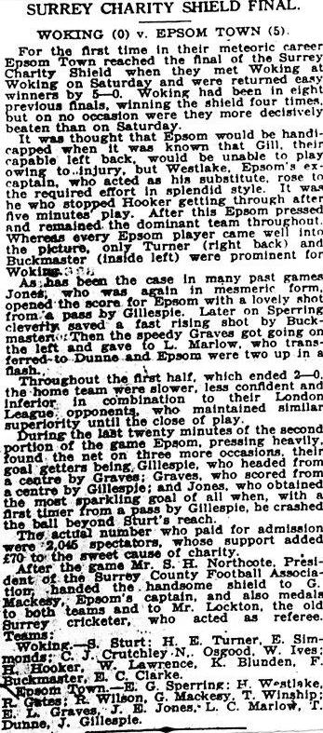
Our next meeting was only a challenge match but produced another eight goals as Marlow scored a hat trick in a 6-2 win at Kingfield in the December of 1927. However, our next meeting would be far more significant as we met in the Final of the Surrey Charity Shield on 22nd April 1933 and convincingly bashed up our opponents on their own patch by five goals to nil (see report)!

The next pair of meetings were also extremely important as the following season we visited them again, this time in the F.A. Cup, where a second half Tommy Dunne equaliser earned us a midweek replay at West Street. On Wednesday 20th September 1933 we trailed again at the half, although this time the lead was extended to 2-0 soon after. However, Bob Gates cleared the ball off the Epsom goal line on the hour and we started to fight back, and Leslie Graves and Leslie Marlow both scored to take us into extra time where the

latter scored another three goals to win the tie 5-2. One of the defining moments of our club history was the First Round F.A. Cup tie at Clapton Orient, but as you can see, we nearly didn’t get past the Preliminary Round!

We met in the Charity Shield again, in 1935, winning once more at Kingfield but things were about to turn. We lost an F.A. Cup tie in 1936 and again in our first match after the cessation of World War Two we were bashed up 8-1. However, one of the most incredible results in our history came on 1st October 1949 at Kingfield again, when we beat them 2-1 in the F.A, Cup. This was all the more incredible when you realise that it was the only away win we would record all season!

Our next four meetings were all lost as Woking were very strong in the fifties and would win the Amateur Cup in 1958 at Wembley Stadium with a 3-0 win over fellow Isthmian Leaguers Ilford. Under the circumstances our 4-2 defeat at West Street that January looked perfectly reasonable by comparison. Our last meeting of the fifties came in September 1959 when we were defeated 3-0 there and that would be our last meeting for fourteen years.

Our 1973 meeting was a Southern Combination Cup tie but it did represent our first win over Woking since 1949 and we were back to normal with a pair of cup defeats in September 1978 and January 1980.

Then came the Surrey Senior Cup Final of 1981 at Sandy Lane, home of Tooting & Mitcham United. We were Third in Division One while Woking were bottom of the Premier Division at the time so it maybe wasn’t much of a giant killing but we took them apart with goals from Tommy Tuite and Micky Stratford and a late consolation made the scoreline of 2-1 look closer than it was.

We narrowly lost 2-1 in the London Senior Cup on my first visit to Kingfield on 18th January 1983, despite our goal being a comedy back pass own goal. However, we were back there in August, as Woking were relegated and we beat them 2-1 home and away that season as we earned promotion, while Woking would drop as far as Division Two South for a couple of seasons.

That’s where the fun ended. They have won the five meetings since then, four of which were in the Surrey Senior Cup. They of course bounced back under the Management of Geoff Chapple and won the F.A. Trophy and now reside comfortably in the National League. They are a very successful club and record stands comparison with any other club of our level, except of course that we did used to be a bit higher ourselves!

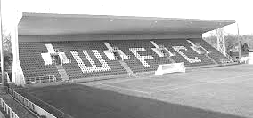

The impressive end stand at Woking, opened in early 1999

Above and Below
Ryman League Division One South Table
incl Saturday 3rd March | P | W | D | L | F | A | Pts | GD
Lewes | 34 | 22 | 8 | 4 | 67 | 27 | 74 | +40
Corinthian-Casuals | 36 | 22 | 6 | 8 | 70 | 36 | 72 | +34
Carshalton Athletic | 34 | 21 | 8 | 5 | 70 | 44 | 71 | +26
Cray Wanderers | 36 | 19 | 12 | 5 | 84 | 33 | 69 | +51
Greenwich Borough | 35 | 19 | 10 | 6 | 70 | 33 | 67 | +37
Walton Casuals | 35 | 19 | 9 | 7 | 71 | 41 | 66 | +30
Hythe Town | 37 | 17 | 10 | 10 | 68 | 51 | 61 | +17
Whyteleafe | 36 | 16 | 11 | 9 | 66 | 49 | 59 | +17
Hastings United | 36 | 14 | 11 | 11 | 64 | 58 | 53 | +6
Phoenix Sports | 36 | 15 | 6 | 15 | 60 | 54 | 51 | +6
Thamesmead Town | 35 | 13 | 10 | 12 | 75 | 66 | 49 | +9
Horsham | 36 | 14 | 7 | 15 | 52 | 61 | 49 | -9
South Park | 30 | 14 | 5 | 11 | 57 | 47 | 47 | +10
Chipstead | 36 | 12 | 9 | 15 | 56 | 55 | 45 | +1
Herne Bay | 32 | 14 | 3 | 15 | 57 | 63 | 45 | -6
Sittingbourne | 33 | 12 | 6 | 15 | 50 | 53 | 42 | -3
VCD Athletic | 36 | 12 | 5 | 19 | 59 | 72 | 41 | -13
Faversham Town | 36 | 10 | 8 | 18 | 45 | 59 | 38 | -14
Ramsgate | 35 | 9 | 7 | 19 | 50 | 70 | 34 | -20
Guernsey | 34 | 8 | 7 | 19 | 46 | 78 | 31 | -32
East Grinstead Town | 35 | 7 | 8 | 20 | 46 | 91 | 29 | -45
Ashford United | 36 | 7 | 7 | 22 | 43 | 88 | 28 | -45
Molesey | 34 | 5 | 10 | 19 | 42 | 71 | 22 | -29
Shoreham | 33 | 3 | 5 | 25 | 29 | 97 | 8 | -68
In our last review, Lewes were being chased down by Cray Wanderers, but since then it is Corinthian Casuals and Carshalton Athletic that are now the main threats to their title charge, potentially leaving Casuals to face the playoffs once again. However, there are still a number of matches to play, so it could all change!

What does look more settled in the make-up of the top six themselves. Hythe Town and Whyteleafe look to have too much ground to make up this season and Cray, together with Greenwich Borough and Walton Casuals appear to be set for post-season action.

At the bottom, Shoreham recently beat Molesey at Walton Road but they will surely fail to overhaul the Moles tally, even if they fail to secure another point. This is good news for us as we need as few clubs to be relegated as possible this season for us to have a realistic hope of survival at Step Five and Molesey dropping into our catchment area would be little short of disastrous.

South Park look to be set for a top half finish once they play their large number of games in hand. It has been announced that they are converting to a 3g surface shortly which will enable them to put a stronger challenge in next season and they will be a team to watch next year. Our landlords Chipstead have no relegation worries at all this year and look like a properly established club under Antony Williams now.

I thought this would be Guernsey’s last season, before attempting to progress in a country v country format in the same way Gibraltar did. However, Jersey have just recently had this plan knocked back so it looks unlikely that this option will become a reality in the short term for our friends from “the second island.”

Combined Counties League Division One Table
incl Saturday 3rd March | P | W | D | L | F | A | Pts | GD
Worcester Park | 25 | 21 | 2 | 2 | 101 | 35 | 65 | +66
Badshot Lea | 25 | 17 | 4 | 4 | 76 | 40 | 55 | +36
Cobham | 24 | 17 | 3 | 4 | 76 | 30 | 54 | +46
Sheerwater | 27 | 16 | 6 | 5 | 78 | 44 | 54 | +34
Staines Lammas | 25 | 16 | 5 | 4 | 66 | 33 | 53 | +33
AC London | 28 | 17 | 0 | 11 | 61 | 43 | 51 | +18
Frimley Green | 26 | 15 | 5 | 6 | 66 | 39 | 50 | +27
Raynes Park Vale | 24 | 14 | 1 | 9 | 59 | 44 | 43 | +15
Eversley & California | 27 | 13 | 3 | 11 | 71 | 58 | 42 | +13
Ash United | 25 | 11 | 3 | 11 | 49 | 58 | 36 | -9
FC Deportivo Galicia | 25 | 8 | 4 | 13 | 47 | 59 | 28 | -12
Chessington & Hook Utd | 24 | 8 | 3 | 13 | 59 | 69 | 27 | -10
Kensington Borough | 24 | 8 | 2 | 14 | 39 | 57 | 26 | -18
Farleigh Rovers | 21 | 7 | 5 | 9 | 38 | 50 | 25 | -12
Fleet Spurs | 27 | 6 | 3 | 18 | 47 | 81 | 21 | -34
South Park Reserves | 21 | 4 | 4 | 13 | 30 | 61 | 16 | -31
Bedfont & Feltham | 28 | 4 | 3 | 21 | 36 | 82 | 15 | -46
Bagshot | 25 | 4 | 1 | 20 | 32 | 98 | 13 | -66
Cove | 25 | 2 | 3 | 20 | 25 | 75 | 9 | -50
It is inevitable to avoid casting an eye over the teams currently below us this season and without a further improvement in our results and a bit of help from clubs around us, this may well be a look at 2018/19 for our club.

Whilst our season has been a difficult one, circumstances elsewhere are really helping us, in the event we could somehow get ourselves off the bottom.

I referred earlier to Shoreham being almost certain to drop, and assuming that we promote two from our own division, then it would be a straight three up, three down situation between our division and this one. However, the top club Worcester Park are not eligible for promotion. In fact, they are due to be relegated at the end of the season as they do not currently meet the Step Six guidelines and the F.A. reorganisation will presumably place them down in the Surrey Elite League at this rate.

Now, whether they are relegated or not isn’t the issue for us; the really important part from our perspective is whether they would block other teams from promotion, which would mean that fewer clubs from our division could be relegated!

Whether Sheerwater (or even Staines Lammas who have games in hand but also face relegation) finish in the top three at the end of the season is of course still up for debate as Cobham, and Badshot Lea look most likely to claim the spots right now, but Worcester Park seem certain for a promotion place, so if one of those other non-promotable clubs finish in the top three also, then only one club would probably go down.

If I’m honest, it still looks like two teams will drop from our division and this means we would need to finish above two other teams to survive. In fairness though, if we are able to bridge the gap between us and Farnham Town, then it’s a much smaller jump to the rest as Godalming Town proved recently.

Centre page for results

Centre page for results



Buildbase F.A. Vase
Fifth Round – 3rd February
Wolverhampton SC | 3-4 | Leighton Town
Thatcham Town | 2-1 | Bromsgrove Sporting
Marske United | 2-0 | Bradford Town
Coleshill Town | 2-4+ | Bracknell Town
1874 Northwich | 1-0 | Chichester City
Stockton Town | 3-0 | Stourport Swifts
Windsor | 2-0 | Hamble Club
Melksham Town | 2-1 | Tring Athletic
Quarter-Finals – 24th February
Bracknell Town | 0-3 | Marske United
Melksham Town | 0-1 | Thatcham Town
Stockton Town | 2-0 | Windsor
Leighton Town | 0-1 | 1874 Northwich
Semi-Finals – 17th March & 24th March – two legs
Stockton Town | V | Marske United
1874 Northwich | V | Thatcham Town

Combined Counties League Cup
Quarter-Finals
Godalming Town | 0-2 | Knaphill
Spelthorne Sports | 1-3 | Walton & Hersham
Sutton Common Rovers | 2-1 | Cobham
Worcester Park | 5-2 | Colliers Wood United
Semi-Finals
Worcester Park | 24/3 | Sutton Common Rovers
Walton & Hersham | 20/3 | Knaphill

Surrey Senior Cup
Second Round
Leatherhead | 2-0 | Kingstonian
Epsom & Ewell | 0-5 | Merstham
Farnham Town | 0-3 | Met Police
Westfield | 2-3 | Colliers Wood United
Spelthorne Sports | 0-4 | South Park
Sutton United | 7-1 | Molesey
Chipstead | 3-2 | Tooting & Mitcham United
Dorking Wanderers | 2-1 | Carshalton Athletic
Quarter-Finals
Met Police | V | Leatherhead
Colliers Wood United | 0-6 | Dorking Wanderers
Sutton United | 1-2 | Merstham
Chipstead | 0-1 | South Park
Semi-Finals
Dorking Wanderers | V | Met Police / Leatherhead
Merstham | V | South Park

100 Years old Today?
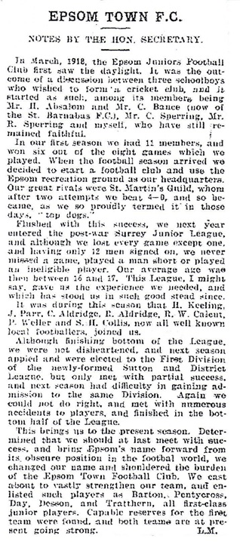
Despite spending approaching twenty years working solidly on our Club History I am unfortunately unable to categorically confirm that we were born 100 years ago today. But we might have been! What is certain is that we were founded 100 years ago this very month according to Len Miller, one of our very first Club Secretaries who was also an original playing member when we first saw the light of day. Here are his memories from the long departed, but very useful Sutton & Epsom Illustrated Newspaper in 1922:

Our club started under the original name of Epsom Juniors, changing to Epsom Town in 1922, Epsom FC in 1934 and finally Epsom & Ewell FC in 1960. Despite the changes we have now spent over half of our existence under our current name, which was created as an attempt to pick up support from the whole Borough and not just the town of Epsom. Obviously at this time we were playing in Ewell Village!

So, over the last hundred years, what have been the main reasons for our success? Obviously we have had many fine players, including the founding members and early drivers of the club, twins Ernie and Reg Sperring. (Ernie is referred to as C.Sperring in the letter!) However, this letter from Len Miller coincided with the

turning point in making our club a successful entity after a handful of years as effectively an overage Youth team. The main catalyst for this change was a man by the name of Hugh Cyril Bradley (pictured left).

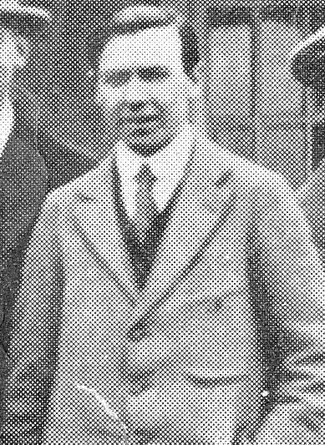
Bradley was purely and simply a visionary. He was the man who had the idea of creating a post-war local League and with the backing of Sutton United Chairman Jack Goossens (whose son Louis would play for Epsom in the late twenties), the pair of them created the Sutton & District League which still exists to this day, closing down only for World War Two. It too will be celebrating its Centenary shortly, being formed in 1920 and with Epsom Juniors as one of its founder members.

He was originally the Secretary of one of the clubs in the League, the Old Suttonians and was a Sutton Grammar Schoolboy. However, he moved to Epsom soon after and was clearly intrigued as to why the town had never had a team of the status of a Sutton United or a Wimbledon, bearing in mind that our town was as big as both of these, and arguably remains so.

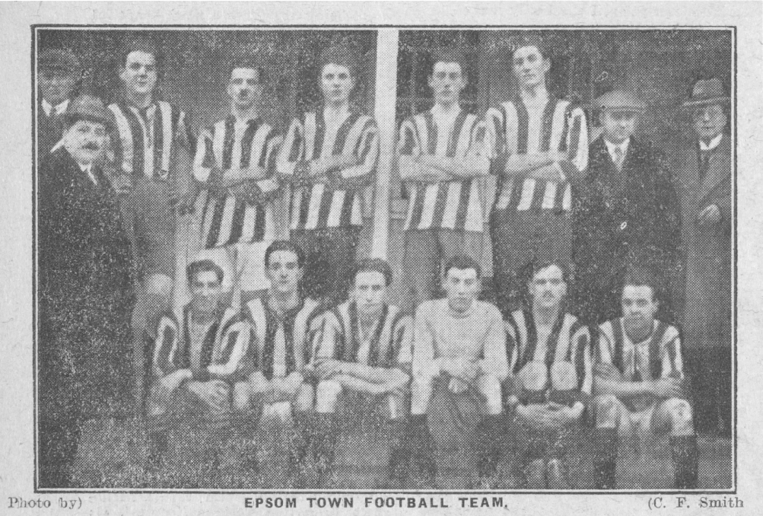
The earliest Epsom Town team line up I have found - 25th November 1922
Epsom Town 5-3 Epsom Brotherhood - Surrey Junior Cup Third Round

He wrote out to both Epsom clubs, the Juniors and their League rivals the Epsom Brotherhood to see whether they would be prepared to pool resources and become a representative “Town club”. However, the Brotherhood had just secured their own ground, which was at Stones Brickworks, very near to Kiln Lane, Epsom. In fact there remains a Brickworks Centre nearby to the site of the ground to this day. They were also arguably the more successful of the two teams and with a religious background were probably not interested in a grand scheme like Bradley’s.

It appears that the Brotherhood declined Bradley’s offer, because within a few months he became heavily involved with the Juniors and they had moved grounds from the Epsom Recreation Ground (better known as Alexandra Recreation Ground) to the Sports Ground at Horton Hospital. By the time the Town, as they were known by then, posed for the team picture on the previous page against Epsom Brotherhood they were asserting a dominance they would never relinquish. Bradley became Chairman in 1923.

The win in the Surrey Junior Cup took Epsom Town into the Fourth Round (last 32) where we were drawn against another local club, Ewell F.C. They were a club formed after the war, with no connection to the Ewell team that had been founded in 1890 and reached the finals of the Surrey Senior Cup and Shield in the final years of the nineteenth century. Actually, there was one connection. The new Ewell team had taken up residence at the ground of their predecessors, in West Street, Ewell Village, so on 16th December 1922 our team made its first ever appearance there, defeating the home side by five goals to two.

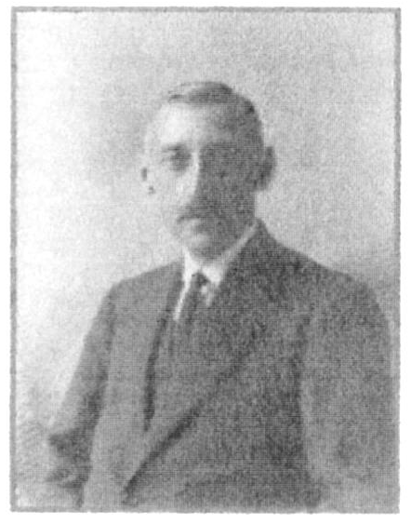
Of course, nobody knew at the time that we would end up reaching the Final of the prestigious County Cup Final, losing after extra time in a replay, largely due to injury to Reg Sperring, or that we would end up securing West Street for our own uses just two and a half years later. The Horton Sports ground had a fantastic playing surface and we were able to gain a unanimous vote in our favour when applying for the Surrey Senior League in 1924. However, the site could not be enclosed and we were unable to receive gate revenue. Attempts were made at raising revenue by way of selling match programmes, with the first one produced in September of 1923, but relying on donations to survive was an issue and may have led to our removal from the League and a place back amongst the local junior clubs.

Bradley appealed for help in finding a ground and found a sympathetic ear. Robert Bradshaw (pictured left) was the son of a Victorian era Admiral and was in a very high position with Taylor Walker Breweries. He had been Captain of Epsom Golf Club in 1920 and was clearly not short of a bit of money!

Bradshaw purchased the ground at West Street in the summer of 1925 for the princely sum of £1,250 and promptly leased it to Epsom, donating £500 and asking them to pay back just £750 over the next twenty-one years. It was this sole act of generosity that enabled us to survive then, and also, to this very day, as we survive on the remnants of the proceeds of the sale of the ground some years later.

Success followed immediately with the club winning the Surrey Senior League in 1926 and then repeating the title triumph a season later, adding the League Charity Cup for good measure. 1927/28 would also provide us with success as we stepped up to the higher level of the London League and we would win this too, although confirmation of the League title on 5th May 1928 was regretfully followed four days later by news of Bradshaw’s tragic death at the early age of 54. He is buried in Epsom Cemetery.

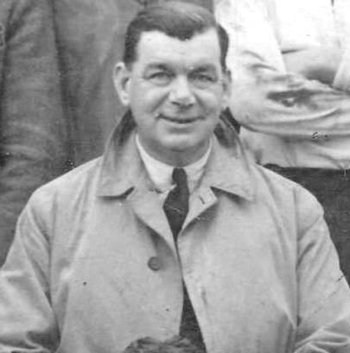
1927/28 was also the year of another important loss as Bradley resigned the Chairman’s position and left the club. It is not clear why he did this. It could have been business related and most likely was the case. In his place came Herbert Charles Pettett, who would be Chairman until the declaration of war; as I write, still the longest tenure of any Chairman.


Under Pettett’s tenure our club would have a very successful period, reaching the Surrey Senior Cup Final in 1929 (see medal), reaching the First Round of the F.A. Cup in 1933 and being runners-up in the London League on five separate occasions during the thirties; three of those behind our nemesis Park Royal.

The decade would of course end with the declaration of World War Two on 3rd September 1939 although by this time there was another Epsom team in the Senior ranks. In fact there was a third as Epsom Manor had just gained entry to the Surrey Senior League too, but I am referring to Epsom Town, who were a completely new team, sharing at West Street and who were also entered into the

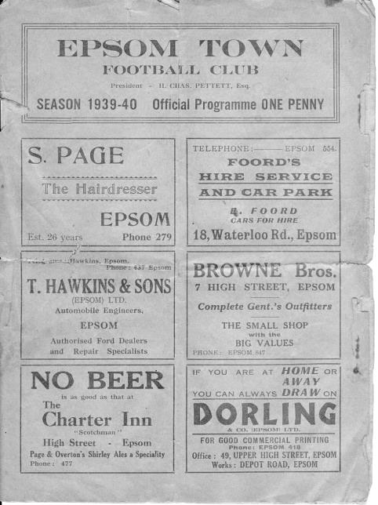
Surrey Senior League. They played just one match, the day before War was declared. (see programme left) but after this, the main Epsom club voted to suspend activities.

This angered Pettett who felt that the cinemas were still running, so football should too, if for no other reason than to boost morale in the local area. He became the driving force behind the new Town club and they kept going throughout the war without a break. Very few clubs can boast this.

It is easy to see why many people think this club was in fact our club. As ours closed, theirs appeared to come from nowhere and many club histories I have seen indicate that we played a particular club, when it was actually Epsom Town!

Of course, when war ended in 1945 the parent club reclaimed the ground and clearly there was some animosity between the club and its former Chairman and they refused to let the Town continue there, forcing Pettett out and consigning the Town club to a season at Lavender Avenue, Mitcham before relocating to Ruxley Lane at the Old Halleyburians ground that still exists today. However, Epsom Town did not last beyond that season and folded in summer of 1946.

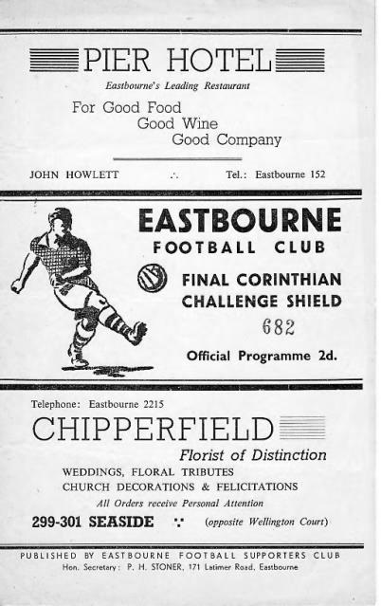
In these austere times our club returned to the London League where they performed unspectacularly until fate intervened on 30th April 1947 when a fire gutted the grandstand and facilities of local rivals the Post Office Engineers. This hurt their club badly and many players stayed for one season but then joined forces with Epsom. The 1948/49 season was a much more successful one as a result and in August of 1949 we moved into the Corinthian League, only formed in 1945 and ironically with Epsom Town as one of its founder members.

Times were hard and we went two and a half years before recording our first away win and at the end of the season we were in the League Cup Final, in April 1952 losing narrowly 2-1 after leading for a long time against the all-conquering Hounslow team. (see programme right)

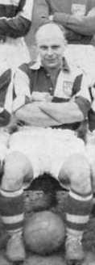
Our fortunes improved further as we appointed the former Hendon Captain Pat Lynch (pictured left) as our Player/Coach. Pat had recently played in the famous 1951 Amateur Cup Semi-Final and replay against Pegasus where a missed penalty would cost them a place at Wembley.

Under his tuition we recorded our highest finish in the Corinthian League of third in 1952/53 and we again reached the Surrey Senior Cup Final in 1954 losing narrowly to Corinthian Casuals (see medal).

Success would be hard to come by after this and the only other major item of note was the sale of the ground in 1959 to John Martin. The club had completed the

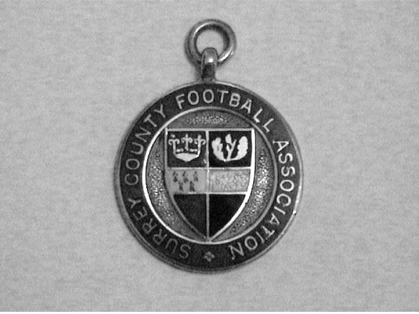
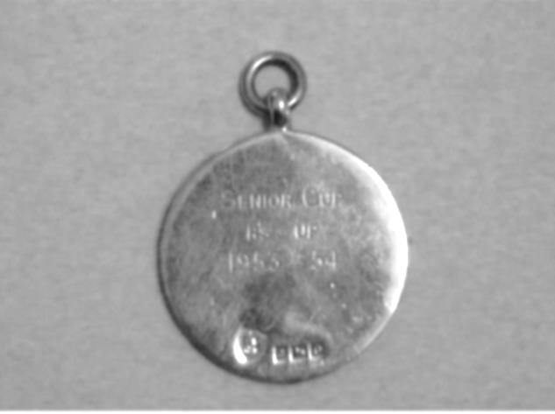
formalities of purchasing the ground from the Trustees of the estate of Robert Bradshaw back in 1938, but now sold it on with a 15 year lease back to the club.

Looking back this appears to be a mistake. We did attract some very good players for a year or two and won the Corinthian League Memorial Shield, but the rest of the sixties are best glossed over frankly.

And worse was to come. In 1973 after seasons of poor results we failed to be elected to the Athenian League and were fortunate indeed to be accepted into the Surrey Senior League at the last minute. After almost fifty years we were back where we started!

Things improved on the pitch from that point with the addition of our new Manager Pat O’Connell, a former professional player with Fulham and he brought many players in from the Wimbledon Reserve team that he had previously been at. Most famously Tommy Tuite, a young 18 year old striker who would go on to break a number of club records. He was fast, durable, and knew where the goal was. Tommy had previously played a couple of games for the Wimbledon first team in the Southern League, so to take on Surrey Senior League defences there was only likely to be one winner!

Pat O’Connell (left) and Tommy Tuite (above). Both players are now living in retirement with Pat in Box Hill at the age of 80 and Tommy in Wallington at the age of 63.

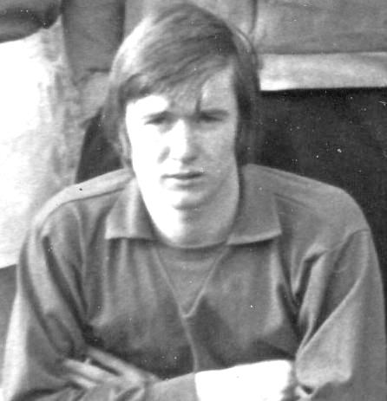
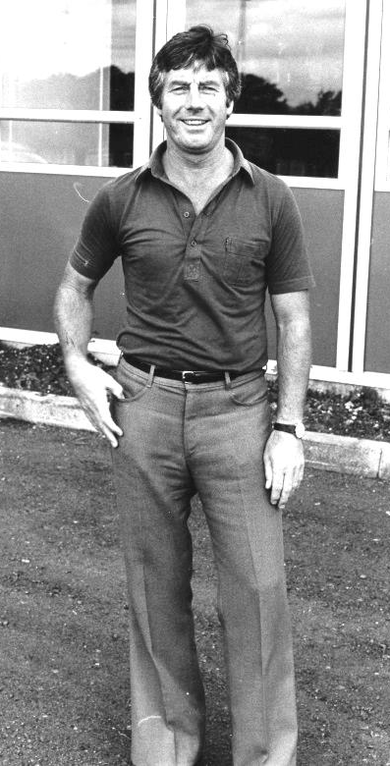
Many other players of quality like Willie Bennett and Trevor Wales came in and dovetailed with current playing members like Alan Webb and Colin Rose.

The following season 1974/75 has obviously been well documented but to summarise, the squad was strengthened further by the return to the club of Johnny Eales, a former Glyn Schoolboy who had played in two previous spells and Dave Worby, an experienced centre-half who still holds the appearance record at Walton & Hersham, where an injury robbed him of an appearance in the 1973 Amateur Cup Final at Wembley Stadium. Over the first couple of months Pat added Trevor Lee and Phil Walker, two exciting young players that had been rejected by League clubs and had been plying their trade at Cobham. Equally important to the cause was Steve Jones, who was also playing at the Leg O’Mutton ground but also drove Trevor and Phil to the matches!

All of these players mentioned, including O’Connell who was still Player / Manager at the time, would grace the pitch at Wembley Stadium in the Final of the F.A. Vase on 19th April 1975 when they were narrowly defeated by Hoddesdon Town. Worby finally earned his chance to play there, although was only able to receive a losers medal.

However, there were still problems off the field. The 15 year lease was running out and the owner wanted to build houses on the site; something that had been denied by the Council in 1965 and fortunately would be again. Martin reluctantly accepted that there was nothing further to be gained and sold the ground to Crystal Palace Chairman Ray Bloye under the ownership of Matthews Holdings. The ground would be purchased by

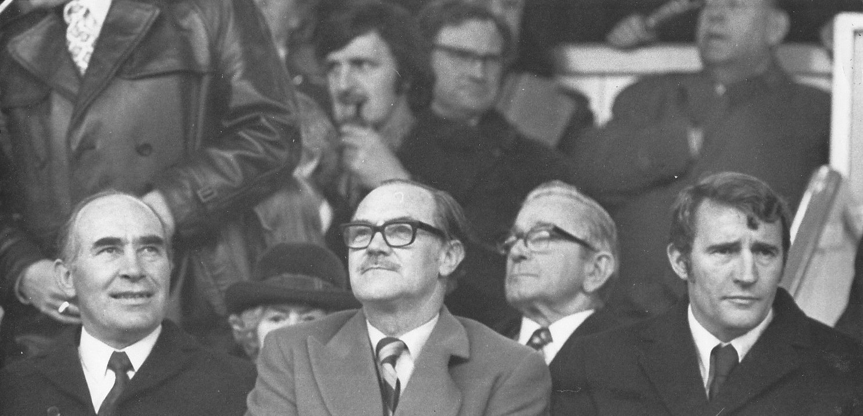

Ray Bloye (pictured centre) at Selhurst Park, surrounded by no less than Sir Alf Ramsey on the left and Malcolm Allison on the far right. In the background can also be seen another instantly recognizable and visionary character, Jimmy Hill.

the Directors of the club once again a few years later and if they hadn’t, then you wouldn’t be here reading this now!

Bloye had personally cleared our club debt in 1973 and installed new people to the Committee as Chairman and Vice-Chairman, Graham Peacock and Ian Grant. The former would remain at the club for a few years while Grant would also go on to be Chairman of our club. They would also join two other people who were already at the club doing sterling work, Dave Wilson and Wilf Smith. Wilf had been there since the late twenties and Dave had joined in 1971. Our current President Stella Lamont joined in 1973 while Stan Bailey joined too, becoming Secretary early in 1974 and remaining for ten years.

With everything settled both on and off the field, it appeared, things began to take off. The Surrey Senior League title had been won in that tremendous season of 1974/75 and the Athenian League welcomed us back with open arms. We went straight through it in two seasons, installed floodlights and entered the Isthmian League in 1977, where we won the Division Two title that following April.

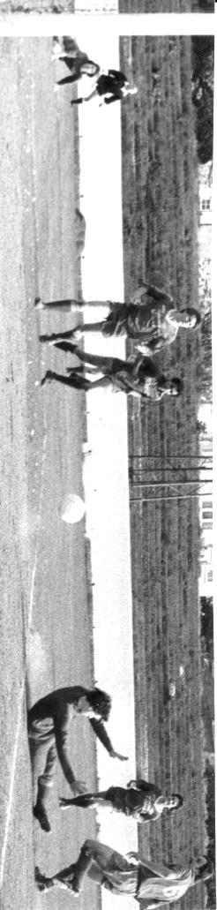
We remained in the Isthmian League Division One for a few seasons, winning the Surrey Senior Cup Final for the only time so far in 1981 with a 2-1 victory over Woking.
Mick Stratford puts us 2-0 up against Woking at Sandy Lane

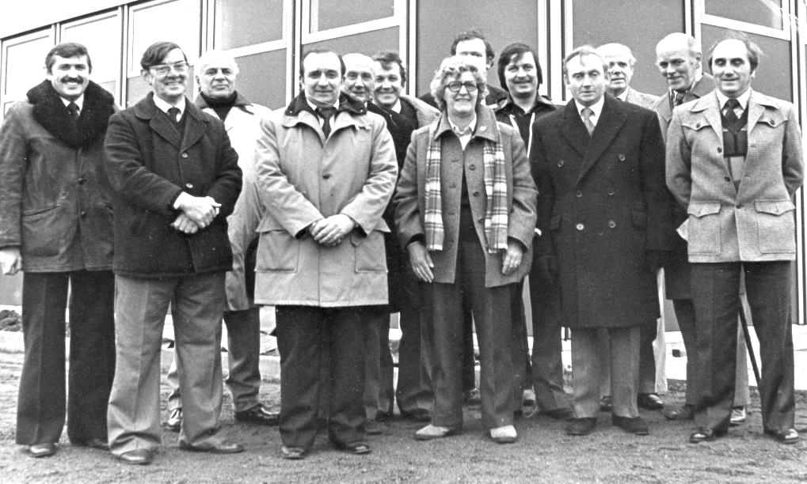
That same season we had opened the new Clubhouse at the ground (see above). It was a substantial construction, previously a works canteen in the Thamesmead area and set the club up for the future.

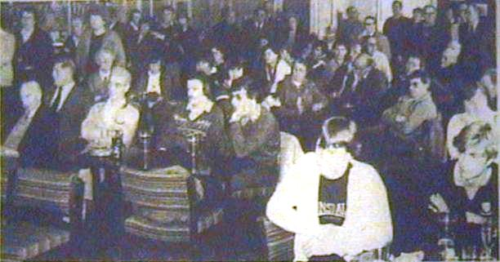
However, within twelve months of the Surrey Cup win there was a problem. In early 1982 it was decided that the finance to the players would have to be cut. This led to an issue between Pat O’Connell and the Committee with the end result being a resignation on 27th February 1982. Most of the squad also went with him, including Tuite who would spend two and a half seasons at Carshalton Athletic, scoring exactly 100 goals in fifty appearances. He would return in 1985.

Chairman Peter Smith took charge of a stormy meeting in the first week of March and

took a lot of the flak. Most, if not all supporters were completely caught out by this chain of events and it was a civil, if strained meeting. I remember being there, seated near the bar while Bill Baxter was doing his best to field questions with a microphone!

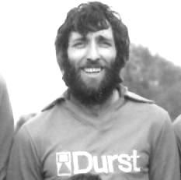
What no one realised at the time was that Smith had one card still to play, the announcement of a new Manager, former player Adrian Hill. Ada was tasked with finding a virtual new squad from scratch with only a few regulars remaining from before the walkout. He brought in experienced keeper Steve Chapman who had been in goal for Colchester United’s famous FA Cup win over Leeds United in 1971 and he added a young player by the name of Alan Pardew to the midfield. It took us until just our second match of the new regime to secure a win and we survived comfortably in the end.

And it got beter still as in Hill’s third season he took us up into the Isthmian League Premier Division behind Windsor & Eton. With other young players destined for football League careers like Paul Harding, Steve Milton and Murray Jones in the squad we were always thereabouts in the race and a good unbeaeten run from March until early May we secured the promotionwith a 2-1 win at Farnborough Town on Tuesday 1st May, a very special evening.

As you might expect, the promotion was dependent on other results and Dave Wilson, by now First Team Secretary, was hanging on the end of the phone line at Cherywood Road waiting to hear confirmation that Windsor had defeated Wembley 2-1 and we were up. We had two home matches remaining anyway, so it always looked like we would be going up by then, but it was still great to think of all the big grounds we would be visiting.

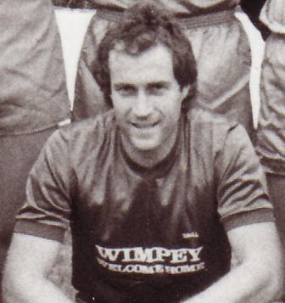
Alas, we would spend just two seasons at that level before being relegated in 1986 and a further relegation the next season caused a major rethink off the field as well as on it. Ada had joined Croydon as Manager in 1985 and long-serving Alan Webb, one of only two Epsom players to receive a testimonial, had failed to keep us in the Premier Division. Ricky Kidd (pictured left) had joined us in that first relegation season and he received his first taste of Management when appointed in September 1986 but we had already lost a number of matches and we went down by a point in May 1987.

Kidd remained with the club until 1990, overseeing the rise of a young Matt Elliott, who would go on to great things with Leicester City but the relegations had affected our ability to raise funds severely and the club had to sell the ground for housing in 1987.

We were given a five year stay of “execution” which then became six as we were granted another year before departing after a final match against Chipstead on 6th May 1993. By which time Ada Hill had returned to the club. Our Chairman by that time was Peter Atkins, pictured far right in the picture below taken on that fateful evening.
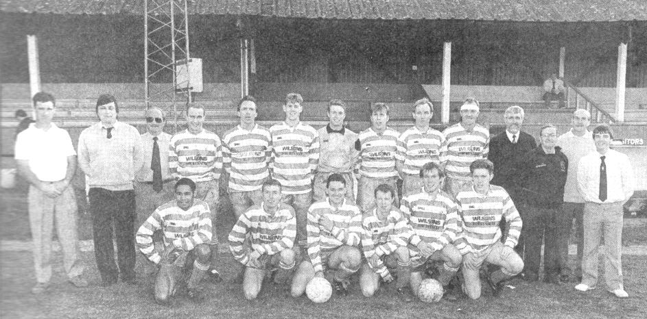

Seventeen years at Banstead Athletic followed, despite the purchase of a site on the Banstead Road, previously owned by General Accident Insurance Company. These were unremarkable years, as indeed were the two that followed at Moatside. Hill had retired in 2003 and we tried a few Managers before former player Lyndon Buckwell came in midway through 2006/07, by which time we had been transferred out of the Isthmian League into the geographically kinder, but a step lower, Combined Counties League.

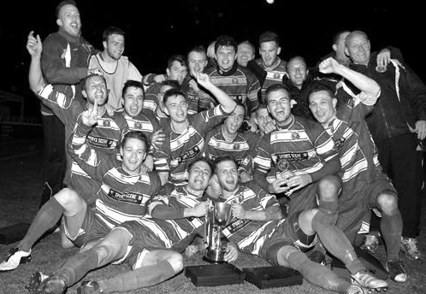
From that day until this we have been one of the stronger teams in the league and won the League Cup in 2013 with a 3-0 win over South Park. Glyn Mandeville carried on the success from 2014 until 2017 and Neil Grant now has the honour of taking us into our second Century.

We remain at Chipstead but have in the last few days submitted a vision to the Council for a site at the Hook Road Arena and await developments with interest as few if any other viable options remain. Still, today is a reason for celebrating our continued existence in the face of adversity and who knows what the future holds for our redoubtable little club. It may be 100 years old but it has fought many battles and still has fight in it for the ones to come.

Some other Memories of our 100 years
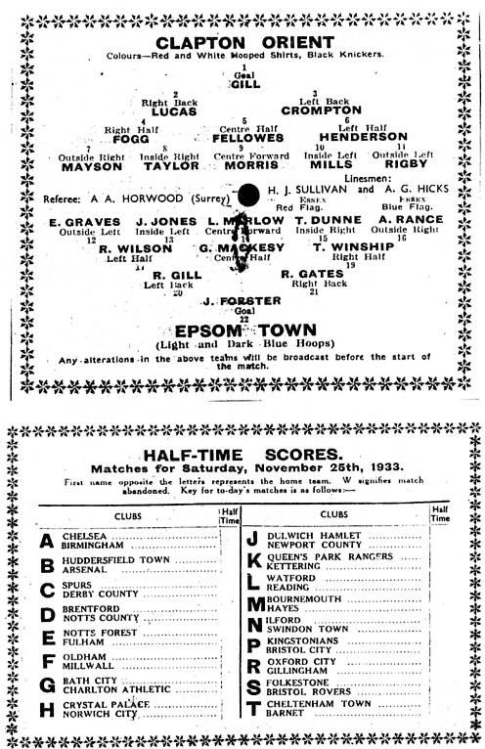
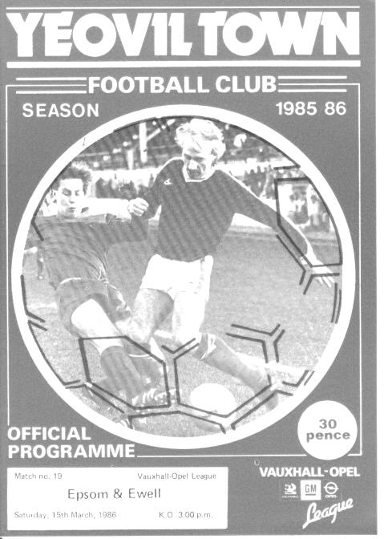
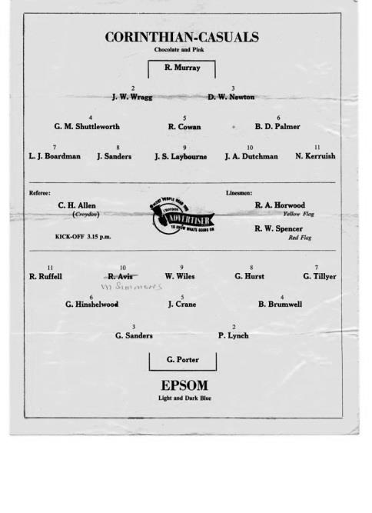
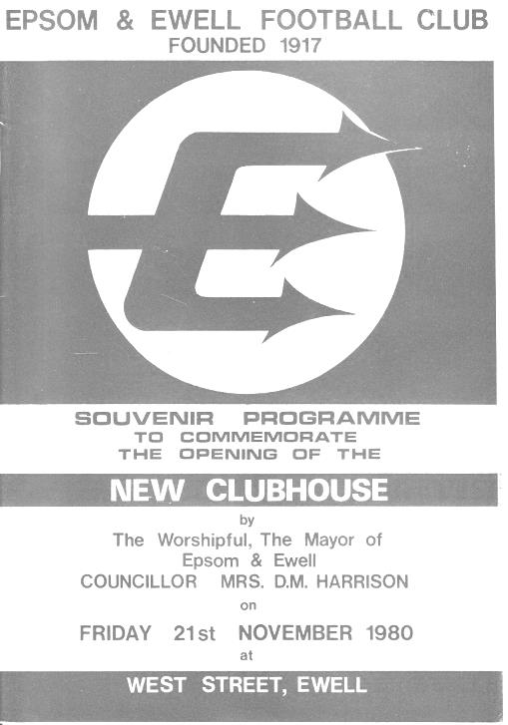

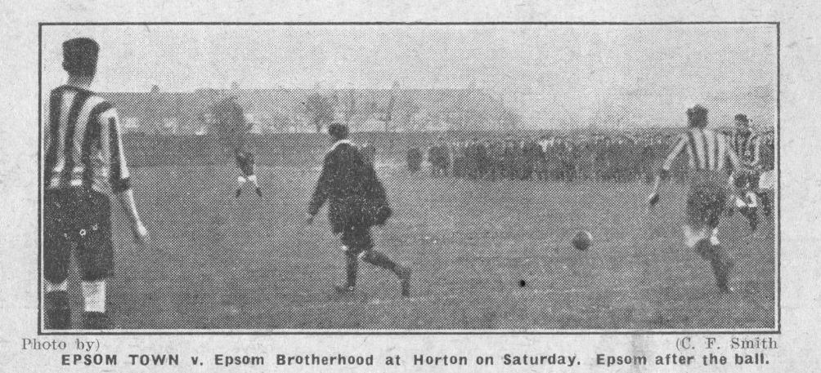
Our earliest known action photo on 25th November 1922 against Epsom Brotherhood in the Surrey Junior Cup, played at our old home ground in Horton Hospital

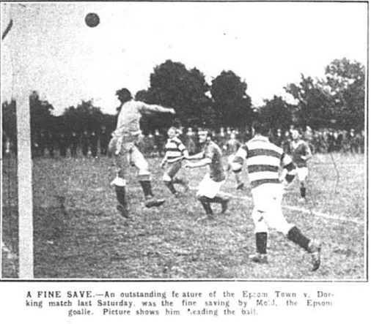
Our first ever Senior match on 30th August 1924 at Horton against Dorking

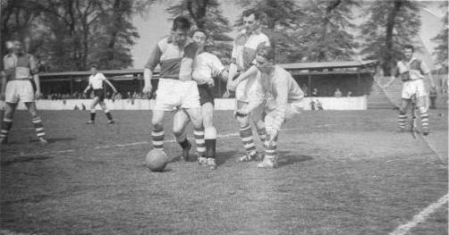

Action from the 1960 Corinthian League Memorial Shield Final at Vale Farm,
Wembley F.C. - Epsom defeated Maidenhead United 2-0

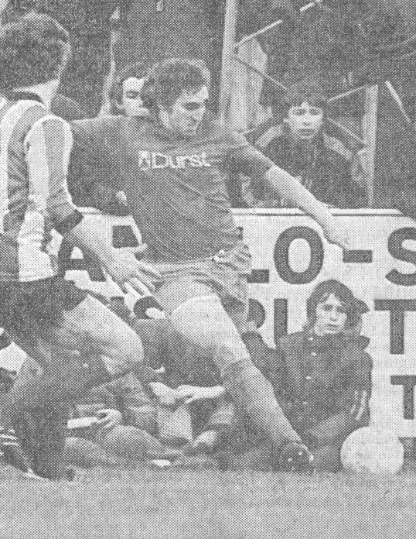
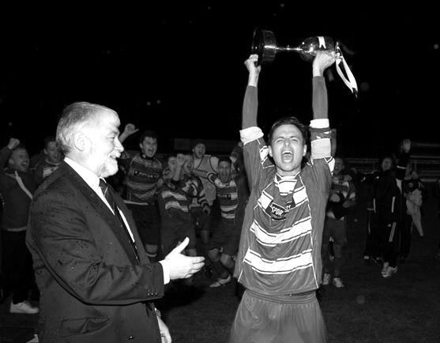
Left: Epsom & Ewell take on Altrincham in the 1982 F.A. Trophy last 32 match with Martin Francis (brother of Gerry) delivering a cross with a young Programme Editor sitting in the background! – Right: Jamie Hatfield lifts the League Cup after defeating
South Park 3-0 at Farnborough Town in the Final on 10th May 2013

Player Sponsorship
Here is the latest list for 2017/18, with new photos showing all of our players and Management that are available for sponsorship. Other new players will be added once the new photos are available.

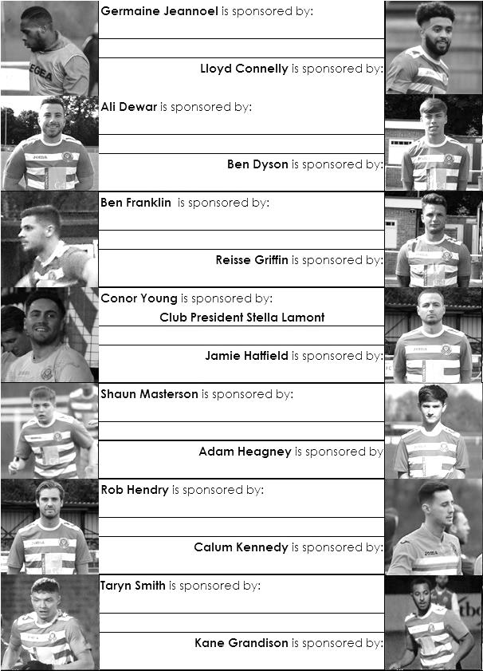

Sponsorship costs just £40 and it is easy to do. Just select a player who has not been previously sponsored and let a Committee Member know. Beware though. Until we have received the money it is possible for someone to jump in front of you, so don’t delay, sponsor today!

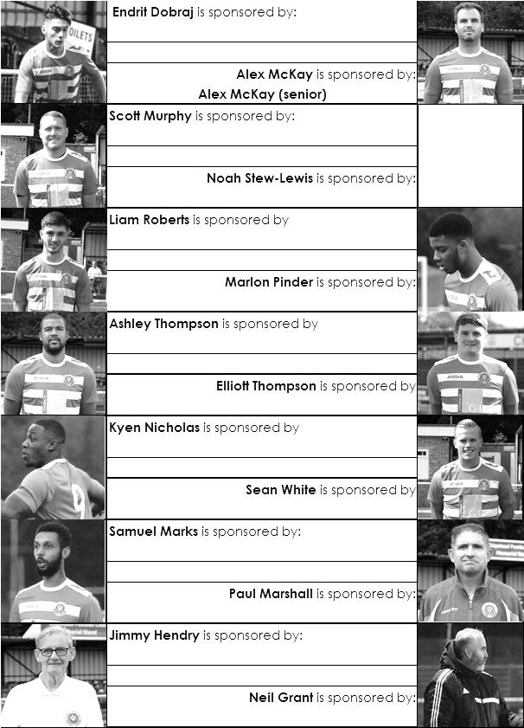

Combined Counties League Premier Division
Opponents All-time Records
inc Saturday  3rd March | P | W | D | L | F | A | PPG | GD | Best  Win | Worst  Loss
Horley Town | 32 | 21 | 5 | 6 | 71 | 37 | 2.13 | +34 | 6-0 | 1-3
Banstead Athletic | 38 | 23 | 7 | 8 | 62 | 38 | 2.00 | +24 | 5-0 | 0-4
Sutton Common Rovers* | 15 | 9 | 3 | 3 | 30 | 21 | 2.00 | +9 | 4-0 | 0-5
Spelthorne Sports* | 9 | 5 | 3 | 1 | 16 | 11 | 2.00 | +5 | 6-2 | 1-5
Godalming Town | 3 | 2 | 0 | 1 | 4 | 5 | 2.00 | -1 | 2-1 | 0-3
Bedfont Sports | 12 | 7 | 2 | 3 | 21 | 19 | 1.92 | +2 | 5-1 | 0-7
Colliers Wood United | 24 | 14 | 2 | 8 | 47 | 39 | 1.83 | +8 | 4-0 | 0-5
Abbey Rangers | 6 | 3 | 2 | 1 | 12 | 5 | 1.83 | +7 | 7-1 | 2-3
Farnham Town | 17 | 9 | 4 | 4 | 30 | 25 | 1.82 | +5 | 3-0 | 1-4
Guildford City | 19 | 11 | 1 | 7 | 36 | 25 | 1.79 | +11 | 5-1 | 1-5
Westfield | 22 | 12 | 3 | 7 | 43 | 41 | 1.77 | +2 | 6-1 | 0-5
Knaphill | 10 | 5 | 2 | 3 | 20 | 16 | 1.70 | +4 | 4-0 | 2-6
Hanworth Villa | 19 | 9 | 5 | 5 | 42 | 30 | 1.68 | +12 | 5-0 | 1-4
Walton & Hersham | 53 | 25 | 11 | 17 | 105 | 101 | 1.62 | +4 | 8-0 | 1-9
Camberley Town** | 91 | 38 | 23 | 29 | 159 | 126 | 1.52 | +33 | 9-1 | 0-4
Redhill | 35 | 14 | 2 | 19 | 63 | 77 | 1.26 | -14 | 7-2 | 2-8
Chertsey Town | 51 | 19 | 5 | 27 | 77 | 95 | 1.22 | -18 | 3-0 | 0-7
North Greenford United | 13 | 4 | 2 | 7 | 19 | 24 | 1.08 | -5 | 3-0 | 1-4
AFC Hayes | 11 | 2 | 3 | 6 | 18 | 20 | 0.82 | -2 | 7-0 | 0-3
CB Hounslow United | 4 | 1 | 0 | 3 | 6 | 11 | 0.75 | -5 | 2-0 | 1-5
Balham | 1 | 0 | 0 | 1 | 0 | 4 | 0.00 | -4 | x | 0-4
* includes one loss on penalties v Spelthorne and one win on penalties v Sutton Common Rovers
** includes one abandoned match v Camberley

Match and Ball Sponsorships – 2017/18
Opponent | Date | Match Sponsor | Ball Sponsor
Banstead Athletic (FAC) | 06/08/17 | Club President - Stella Lamont
Chertsey Town | 15/08/17 | EEFC Management Committee
Redhill | 02/09/17 | Building Shop Ltd
Spelthorne Sports | 09/09/17 | In memory of Betty Dyke
Horley Town | 12/09/17 | Alex McKay (Senior)
Hanworth Villa | 23/09/17 | Jack Jarman
North Greenford United | 28/10/17 | Marvin and Kathy Hough
Farnham Town | 14/11/17 | In memory of Dave and Lizzie Marshall
Godalming Town | 21/11/17 | Building Shop Ltd
Guildford City | 02/12/17 | John Bonner
Walton & Hersham | 30/12/17 | Jeff and Arnold Pye
Merstham (SSC) | 16/01/18 | Paul Merritt
Abbey Rangers | 23/01/18 | Pete Beddoe’s grandchildren  George, Joseph, Ezara & Inaya
Sutton Common Rovers | 03/02/18 | David Ellins
Knaphill | 24/02/18 | Jack Jarman
Camberley Town | 10/03/18 | Pete Lumm
Balham | 13/03/18
Bedfont Sports | 24/03/18
Colliers Wood United | 30/03/18
Banstead Athletic | 02/04/18 | Nathan Lambert – 10 years old today!
Westfield | 14/04/18
CB Hounslow United | 17/04/18
AFC Hayes | 28/04/18 | Club President - Stella Lamont
Match sponsorship costs just £60.00!

Sponsorship includes:

Admission, programmes and hospitality for three people.

A full page advert in the programme and mascot for the day (if required).

Also, you get to choose the player of the match, who will receive a prize

If you are interested, just speak to a Committee Member,
or drop me an email at: richard.c.lambert@gmail.com

First Eleven Appearances 2017/18 - (max 37)
Name | Debut | 2017/18 |  |  |  | Career Totals
Name | Debut | App | Sub | Tot | Goals | App | Sub | Tot | Goals
AJAYI Tayo* | 06/08/2017 | 3 | 4 | 7 | 1 | 3 | 4 | 7 | 1
ANDERSON Miguel | 03/02/2018 | 3 | 1 | 4 | 0 | 3 | 1 | 4 | 0
BROOKS Jordan* | 06/08/2017 | 3 | 0 | 3 | 0 | 3 | 0 | 3 | 0
BURROWES Joshua* | 02/12/2017 | 1 | 1 | 2 | 0 | 1 | 1 | 2 | 0
CASTELL Cristian* | 06/08/2017 | 2 | 4 | 6 | 0 | 2 | 4 | 6 | 0
CAULCRICK Joshua | 17/02/2018 | 0 | 1 | 1 | 0 | 0 | 1 | 1 | 0
CLARK Jordan | 17/02/2018 | 0 | 2 | 2 | 0 | 0 | 2 | 2 | 0
CONNELLY Lloyd | 14/10/2017 | 20 | 3 | 23 | 2 | 20 | 3 | 23 | 2
DEWAR Ali | 29/10/2011 | 1 | 2 | 3 | 0 | 56 | 42 | 98 | 10
DOBRAJ Endrit | 18/11/2017 | 10 | 3 | 13 | 0 | 10 | 3 | 13 | 0
DYSON Ben | 12/08/2017 | 22 | 9 | 31 | 2 | 22 | 9 | 31 | 2
FRANKLIN Ben | 03/03/2015 | 3 | 1 | 4 | 0 | 4 | 1 | 5 | 0
GRAHAM Bentley* | 09/02/2016 | 3 | 0 | 3 | 0 | 20 | 1 | 21 | 3
GRANDISON Kane | 11/11/2017 | 7 | 1 | 8 | 0 | 7 | 1 | 8 | 0
GRIFFIN Reisse | 08/08/2015 | 23 | 0 | 23 | 1 | 96 | 13 | 109 | 7
HARLAND-GODDARD Tom* | 06/08/2017 | 1 | 1 | 2 | 0 | 1 | 1 | 2 | 0
HARRIS Colin* | 04/08/2012 | 9 | 0 | 9 | 0 | 34 | 0 | 34 | 0
HATFIELD Jamie* | 11/11/2006 | 9 | 1 | 10 | 0 | 258 | 14 | 272 | 6
HAYWARD Ben* | 07/03/2007 | 5 | 1 | 6 | 0 | 248 | 29 | 277 | 18
HEAGNEY Adam | 16/08/2016 | 22 | 2 | 24 | 0 | 59 | 11 | 70 | 1
HENDRY Rob | 08/08/2015 | 16 | 1 | 17 | 5 | 84 | 23 | 107 | 28
HOUGH Kyle* | 14/08/2007 | 10 | 2 | 12 | 6 | 343 | 21 | 364 | 207
JASPER Joe* | 11/11/2017 | 0 | 1 | 1 | 0 | 0 | 1 | 1 | 0
JEANNOEL Germaine | 02/12/2017 | 2 | 5 | 7 | 1 | 2 | 5 | 7 | 1
KENNEDY Calum | 18/11/2017 | 2 | 1 | 3 | 0 | 2 | 1 | 3 | 0
LAW Franky* | 06/08/2017 | 3 | 0 | 3 | 0 | 3 | 0 | 3 | 0
LOFTUS-CHEEK Joe* | 06/08/2017 | 10 | 3 | 13 | 2 | 10 | 3 | 13 | 2
MARKS Samuel* | 06/01/2018 | 1 | 2 | 3 | 0 | 1 | 2 | 3 | 0
MARVELL Dale* | 15/01/2000 | 17 | 2 | 19 | 0 | 286 | 51 | 337 | 86
MASTERSON Shaun | 25/11/2017 | 3 | 3 | 6 | 0 | 3 | 3 | 6 | 0
MCKAY Alex | 20/12/2008 | 22 | 1 | 23 | 1 | 153 | 38 | 191 | 13
MULLINGS Corey | 23/12/2017 | 0 | 2 | 2 | 0 | 0 | 2 | 2 | 0
MURPHY George | 19/03/2013 | 2 | 0 | 2 | 0 | 70 | 7 | 77 | 3
MURPHY Scott | 20/01/2007 | 24 | 0 | 24 | 1 | 36 | 2 | 38 | 1
MYERS Antony | 23/12/2006 | 1 | 0 | 1 | 0 | 76 | 33 | 109 | 9
NICHOLAS Kyen | 13/01/2018 | 7 | 1 | 8 | 3 | 7 | 1 | 8 | 3
NWACHUKWU Jason* | 01/10/2016 | 9 | 4 | 13 | 2 | 26 | 20 | 46 | 3
O'BRIEN Louis* | 28/08/2017 | 1 | 3 | 4 | 0 | 1 | 3 | 4 | 0
PINDER Marlon | 13/01/2018 | 5 | 0 | 5 | 1 | 5 | 0 | 5 | 1
ROBERTS Liam | 12/08/2017 | 18 | 9 | 27 | 4 | 18 | 9 | 27 | 4
ROBINSON Sam* | 22/10/2011 | 5 | 0 | 5 | 0 | 66 | 6 | 72 | 14
ROSE Daniel* | 25/10/2016 | 14 | 2 | 16 | 1 | 16 | 7 | 23 | 1
SAMPAT Mohammed* | 23/12/2017 | 3 | 0 | 3 | 0 | 3 | 0 | 3 | 0
SELLICK Rory | 27/01/2018 | 5 | 0 | 5 | 1 | 5 | 0 | 5 | 1
SMITH Andy* | 25/08/2017 | 2 | 0 | 2 | 0 | 2 | 0 | 2 | 0
SMITH Taryn | 28/10/2017 | 7 | 3 | 10 | 0 | 7 | 3 | 10 | 0
STEW-LEWIS Noah | 09/12/2017 | 6 | 2 | 8 | 0 | 6 | 2 | 8 | 0
THOMPSON Ashley | 21/08/2017 | 26 | 1 | 27 | 3 | 26 | 1 | 27 | 3
THOMSON David* | 02/09/2017 | 2 | 2 | 4 | 0 | 2 | 2 | 4 | 0
TURPIE Ali | 31/03/2016 | 1 | 0 | 1 | 0 | 12 | 1 | 13 | 0
WHITE Sean | 02/08/2014 | 14 | 7 | 21 | 2 | 20 | 20 | 40 | 5
YOUNG Conor | 07/03/2015 | 22 | 0 | 22 | 0 | 23 | 0 | 23 | 0
* Player has left the club

Salts Super Six Predictor
The Salts Super Six Predictor jackpot has risen to £491 for today’s match. The tickets are on sale to the left of the gate and the matches on the ticket are to be played today!

The competition is easy to play! To win, you simply need to predict the results of six matches correctly from the three options, fill in the form and make sure it is back with our seller before the deadline on the ticket. The latest fixtures are shown below.

If you are a club regular, you just need to place your name on the sheet, although if you aren’t, then we’ll need a contact number from you too. We will announce any winners on the website within three working days, so don’t worry, we won’t miss you!

Please note that if there is more than one winner, the prize pot would be shared between the winners. All you need to do now is have a go, as many times as you like!

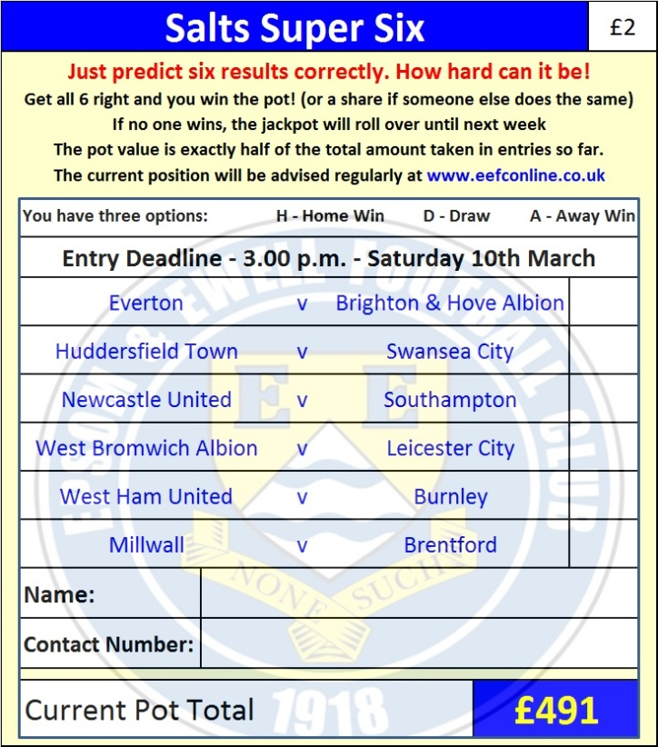

Good luck!

Combined Counties League – Premier Division
Saturday, 10th March 2018 - Kick-off 3.00 p.m.
Epsom and Ewell  (Royal Blue & White hoops) | V |  | Camberley Town  (Red and White)
Squad | NUMBERS |  | Squad
Conor Young |  |  | Adam Desbois
Endrit Dobraj |  |  | Jordan Harrison
Reisse Griffin |  |  | Fred Kelsey
Adam Heagney |  |  | Phil Moore ©
© Alex McKay |  |  | Stuart Derry
Ashley Thompson |  |  | Liam Roberts
Marlon Pinder |  |  | Marcus Cousins
Scott Murphy |  |  | Ryan Bell
Kyen Nicholas |  |  | Adam Francis
Rory Sellick |  |  | Jack Dean
Lloyd Connelly |  |  | Jamie Hoppitt
Noah Stew-Lewis |  |  | Dale Webb
Ben Dyson |  |  | Steve Brown
Liam Roberts |  |  | Jake Charlton
Miguel Anderson |  |  | Mark Jordan
Rob Hendry |  |  | Jake Nicholls
Ben Franklin |  |  | Adam Wareham
Shaun Masterson |  |  | Kevin Wynter
Joshua Caulcrick |  |  | Sam Bello-Balagun
Jordan Clark |  |  | Adam Liddall
Alvin MacAuley
Ryan Gunter
Germaine Jeannoel
Neil Grant | MANAGER |  | Dean Greenwood
Alex McKay | ASSISTANT |  | Emmanuel Noudine / Dale Webb
Jordan Clark / Jimmy Hendry | COACH / PHYSIO |  | Dave Clifford
REFEREE: A.Nayir
ASSISTANTS: P.Maskell, P.Jones
Today’s Match and Match Ball are kindly sponsored by:
former Chairman and long-serving supporter Pete Lumm

OUR NEXT VISITORS TO HIGH ROAD
Balham
Cherry Red Combined Counties League – Premier Division
Tuesday 13th March 2018 – 7.45 p.m.

